Project Report

for Astronomical Observation

(우주관측 SPACE213-00, 2018-2학기, 박수종 교수)

**Astronomical Observation Class**

**Project Report**

Submitted by

*Kim Changgon (김창곤)*

Updated on 2018-12-14

Fall Semester in 2018 by Prof. Soojong Pak

Department of Astronomy and Space Science

Kyung Hee University

TABLE OF CONTENTS

**REVISION HISTORY** **3**

**Project 01. Spherical Astronomy** **4**

1. Introduction 4

2. Experiment with Celestial Sphere Model 4

2. 1. Celestial Sphere 4

2.2. Earth's Rotation 11

2.3. Revolution of the Earth 15

2.4. Time 17

3. Celestial Coordinate System 19

3.1. Horizontal System 19

3.2. Equatorial System 19

3.4. Converting Coordinates 19

4. Suggestions (option) 19

**Project 02. Kyung Hee Astronomical Observatory** **20**

1. Introduction 20

2. Observatory Facilities 22

2.1 Telescope 22

2.2 CCD camera 23

2.3 UBVRI filter 23

2.4 Dome activating facility 24

2.4 Main Computer 24

3. Observation Process 25

3.1 Before observation 25

3.2 Preparation in Dome 29

3.3 Observation by software 34

**Project 03. Observation** **41**

1. Introduction 41

2. Target Selection 41

3. Target Visibility 43

4. Observing Log 47

5. Sample image 49

**Project 04. Data Reduction and Photometry** **51**

1. Data information 51

2. Pre-Processing 56

3. Aperture Photometry 59

**Project 05. Data Reduction & Results using My data** **65**

5.1. Preprocessing 65

5.2. Photometry 69

5.3. Flux calibration 70

5.4. H-R Diagram 73

5.5. Final comments 74

# 

# REVISION HISTORY

* 2018.09.17 I changed the name of report from the first version. The new content is about the celestial sphere model experiment which was in class at 09.14.
* 2018.09.26 I changed Project 02. Kyunghee Astronomical Observatory
* 2018.10.08 I changed some mistakes due to the peer review, and I changed Project 03.
* 2018. 10. 16 I changed some mistakes and I added the plot of airmass vs hour angle in Project 03.
* 2018. 11. 22 I changed some mistakes and I updated the observation data of 11/13.And I revised Project 03. Observation.
* 2018. 11. 28 I updated Project 04. Data reduction
* 2018. 12 .05 I updated Project 04. Data reduction with the data of NGC 225(Demo data).
* 2018. 12. 08 . I updated some small titles and specific mistakes.
* 2018. 12. 14 My final update!

# 

# Project 01. Spherical Astronomy

## 1. Introduction

* What is your assignment in this project?

The main assignment in this project is to understand the **celestial sphere** and the movements of objects on the celestial sphere. Understanding the celestial sphere and applying the concepts in the real sky is quite difficult, as the movement of the objects which is definitely influenced by each other in the outer space looks outwardly complicated in the sky. However, by learning this project, we can recognize that a celestial sphere is a useful concept for understanding the movement of objects in the sky.

* Why do you learn this?

In project 01, we are going to learn about **spherical astronomy**. In spherical astronomy, celestial objects are located in an imaginary sphere with an arbitrarily large radius that has the Earth on the center and the sphere is defined as the celestial sphere. So the positional measurement of objects on the celestial sphere is focused on how the objects appear in the sky that we see. This is an important factor in observation as the positional measurements from the observation are interpreted in the celestial sphere and these measurements determine the variety of physical quantities that gives critical information of the objects in astronomy.

## 2. Experiment with Celestial Sphere Model

### 2. 1. Celestial Sphere

* 
* (Figure 1.1)

In astronomy, the **celestial sphere** is an abstract sphere with an arbitrarily large radius concentric to Earth. All objects in the sky is located upon the inner surface of the celestial sphere, which may be centered on Earth or the observer. As we can look at figure 1.1, the Earth is rotating in the center of the sphere and the red line is the ecliptic circle, the passage of Sun, and the lines of right ascension and circles of declination are the lines of equatorial coordinate system. So this is the fundamental factors of the celestial sphere, and now we are going to confirm other factors and stars upon the celestial sphere by our celestial sphere model.

* Ref: <https://en.wikipedia.org/wiki/Celestial_sphere>
* 2.1.1 The positions on the celestial sphere model.
* 1) The experiment starts as marking the following positions on the Celestial Sphere Model.  
  Objects : North Pole, South Pole, Equator, Arcturus, Vega, Betelgeuse, Crux  
  Ecliptic North Pole, Ecliptic South Pole, Ecliptic

Vernal Equinox, Summer Solstice, Autumnal Equinox, Winter Solstice  
Horizontal plane, Zenith, North, East, South, West, Meridian Circle

* 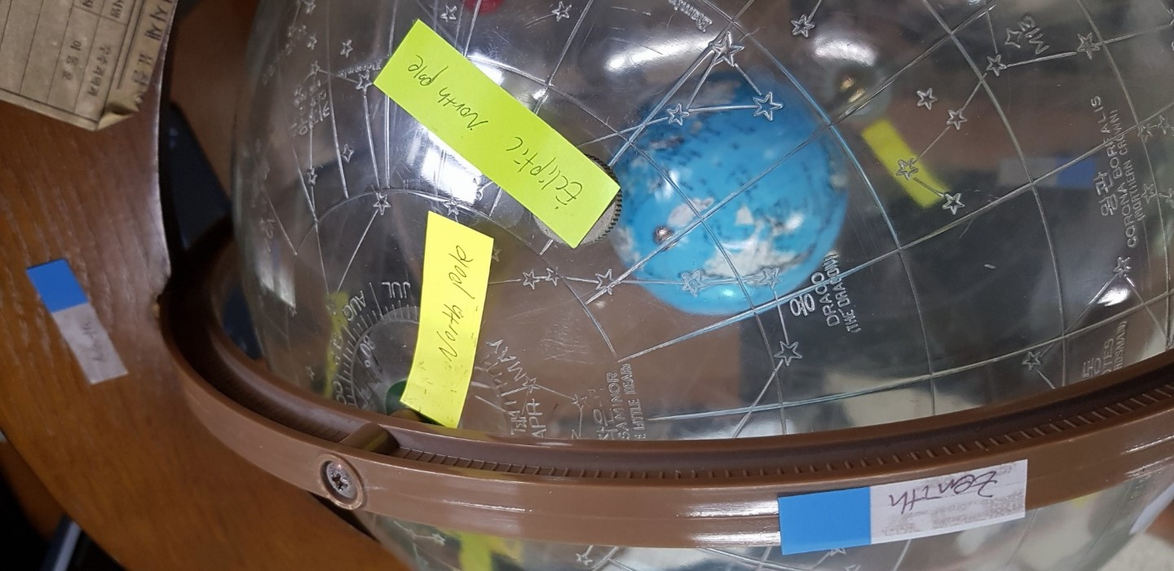

Example 1.1 North pole and ecliptic north pole

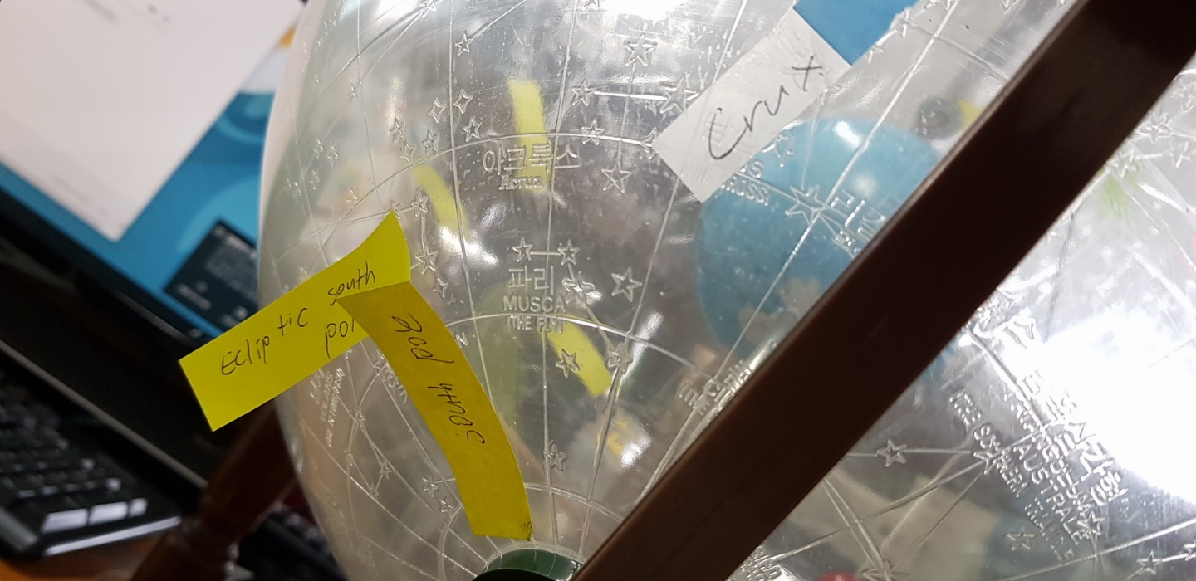

Example1.2 South pole and ecliptic south pole, Crux

* 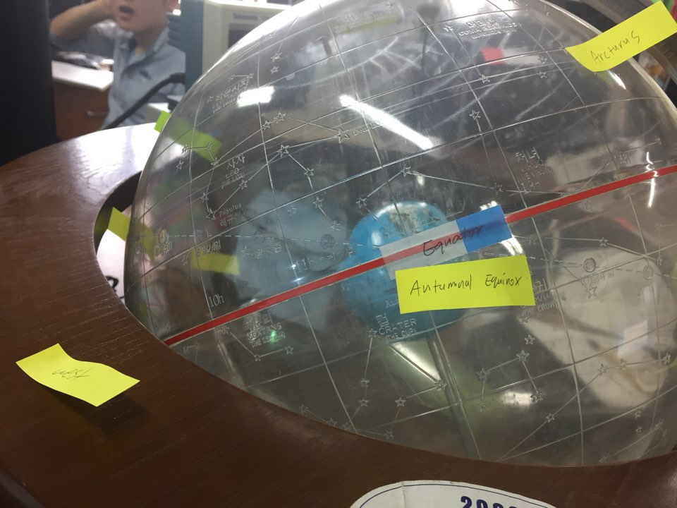

Example 1.3 Equator and Autumnal Equinox

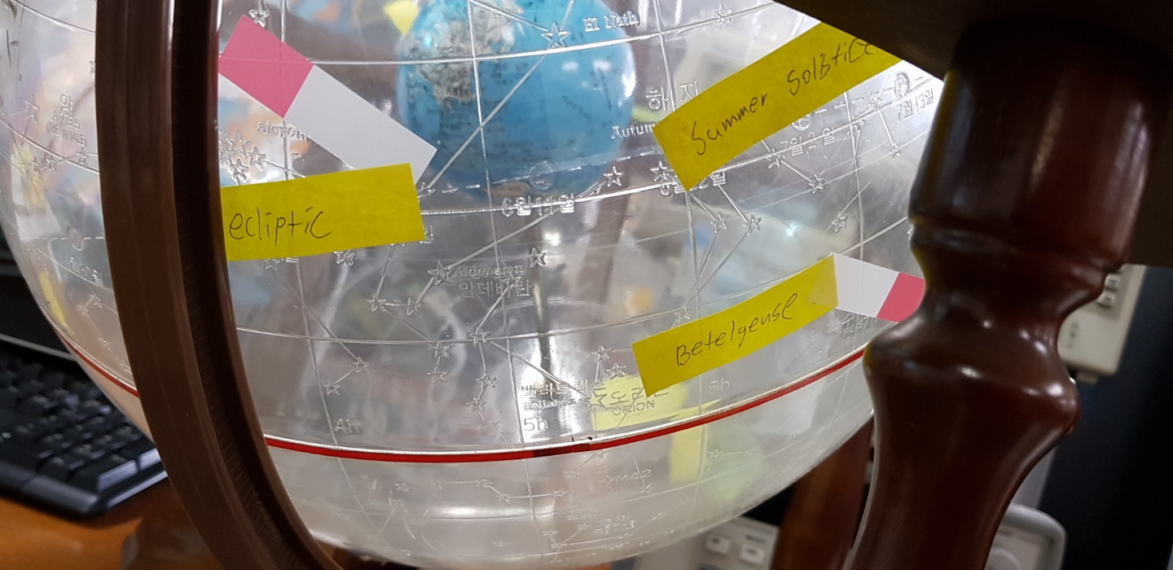

Example 1.4 Ecliptic and summer solstice

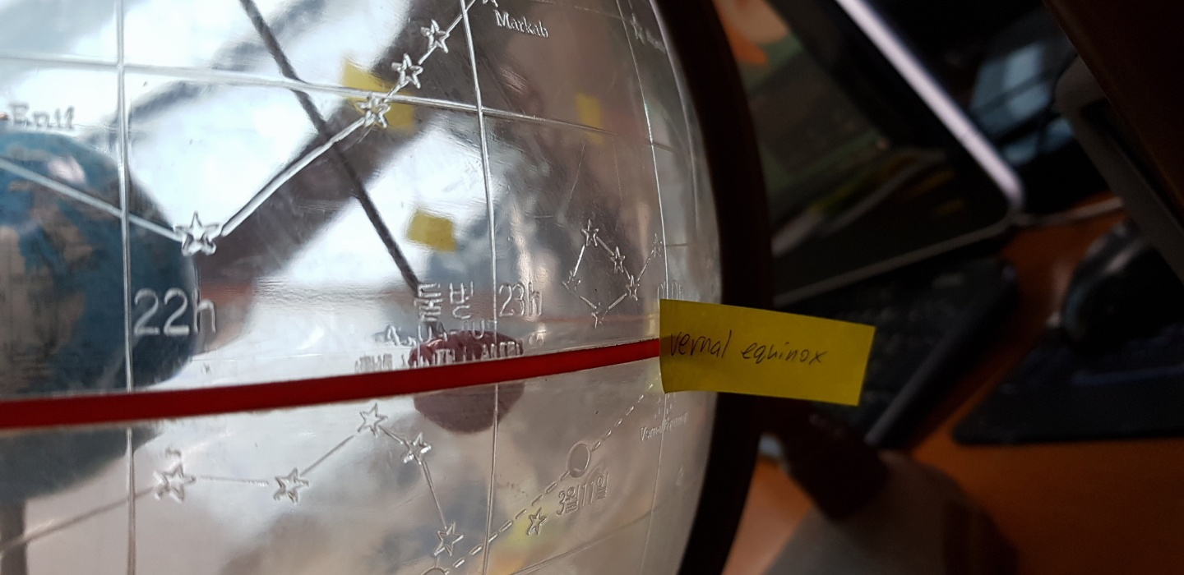

Example 1.5 vernal equinox

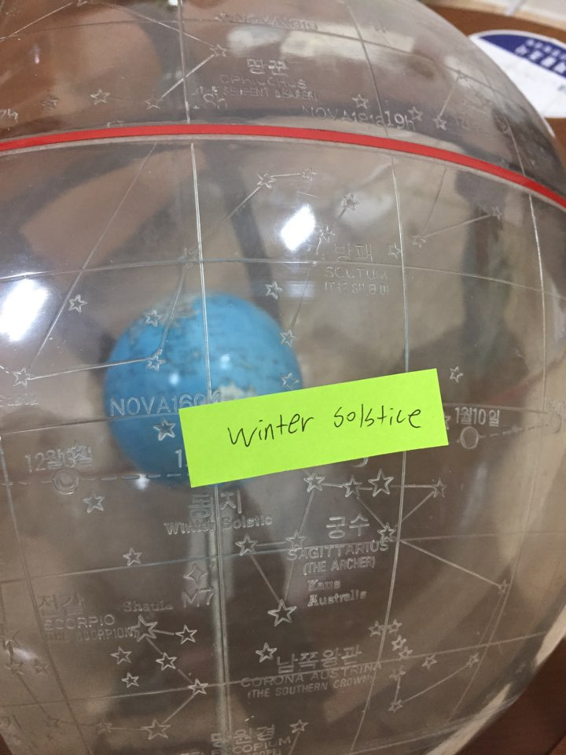

Example 1.6 winter solstice

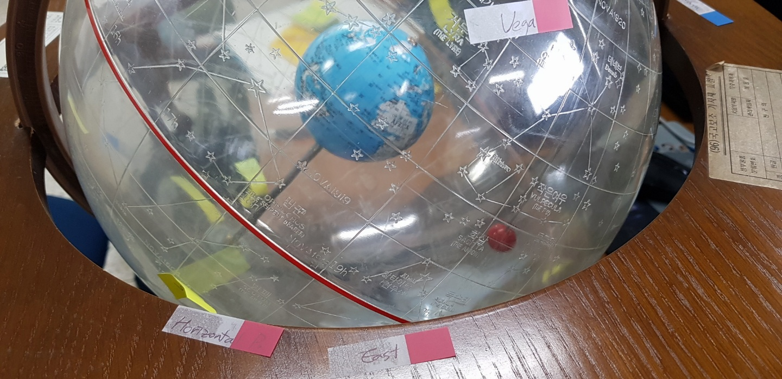

Example 1.7 Horizontal plane and East, Vega

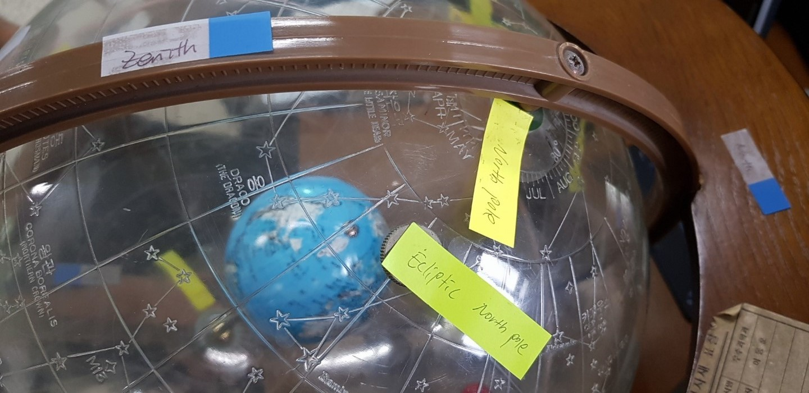

Example 1.8 Zenith

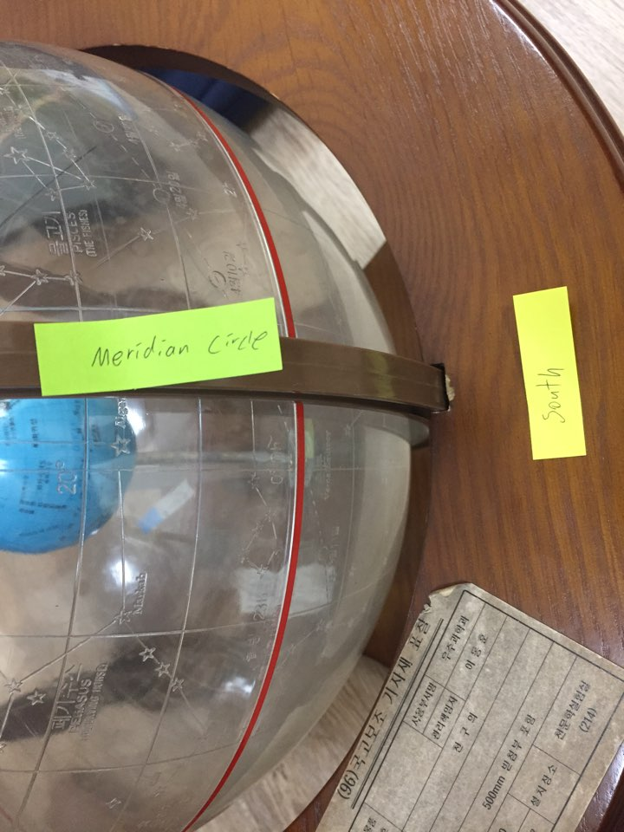

Example 1.9 Meridian circle and South

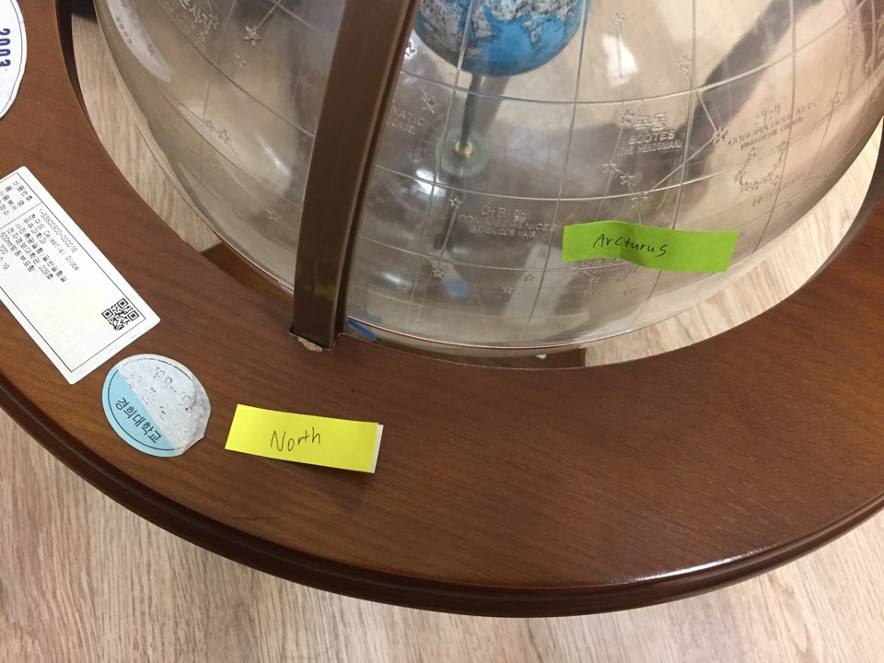

Example 1.10 North and Arcturus

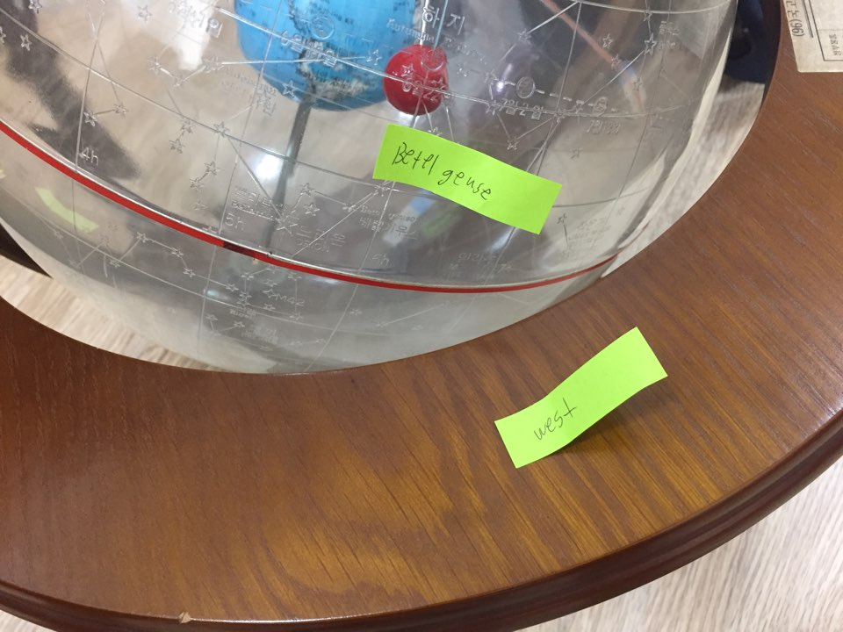

Example 1.11 West and Betelgeuse

* 2.1.2 set the model for the following location.
* Imagine if you are at the following places : north pole, south pole, Suwon, Sydney.
* Observe how the celestial sphere changes when the location on Earth changes.
* Especially, look at the equator and zenith, and make some rotation of Earth at each location.

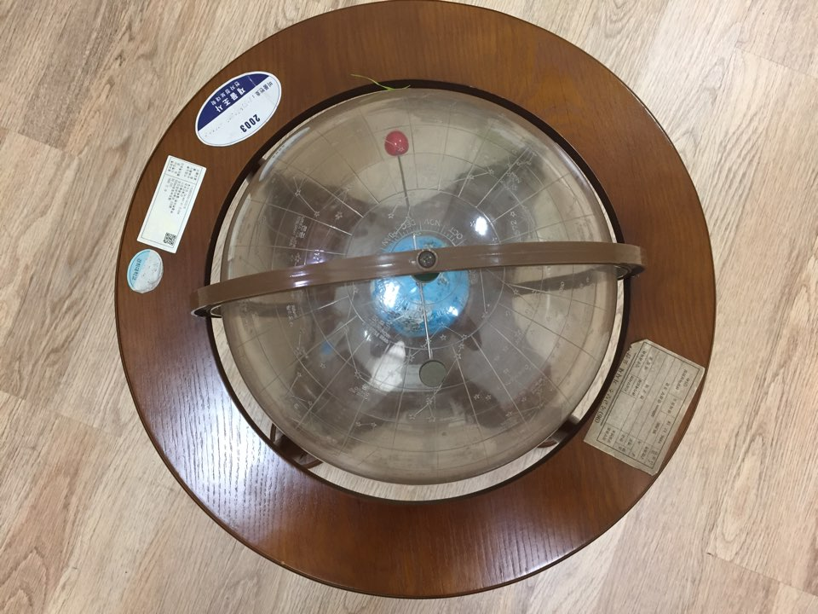

* + - * + Example 1.12 North pole

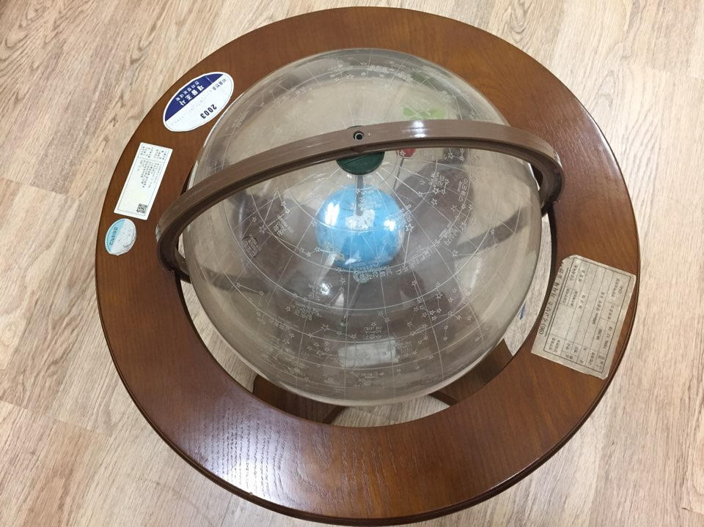

Example 1.13 South pole

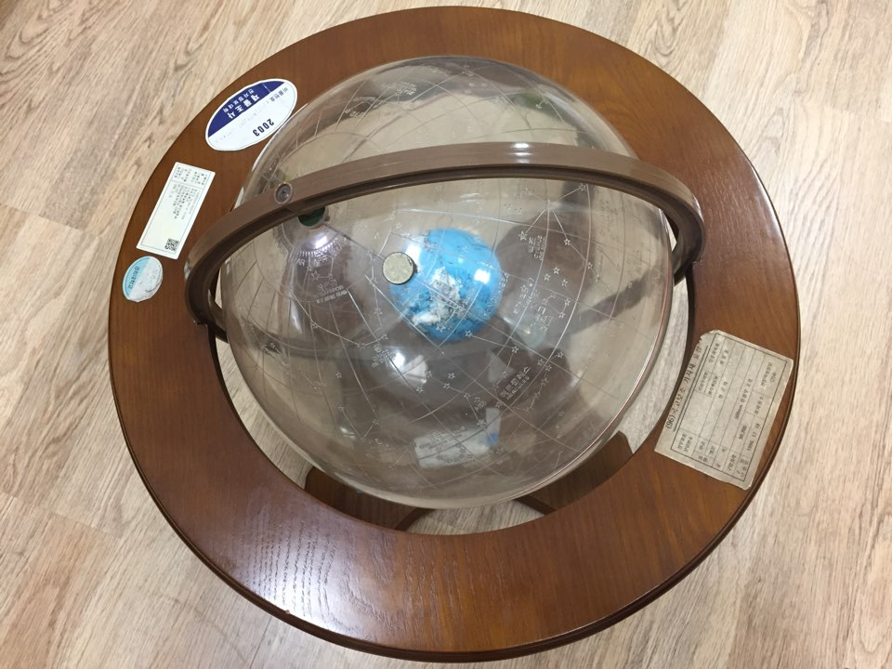

Example 1.14 Suwon

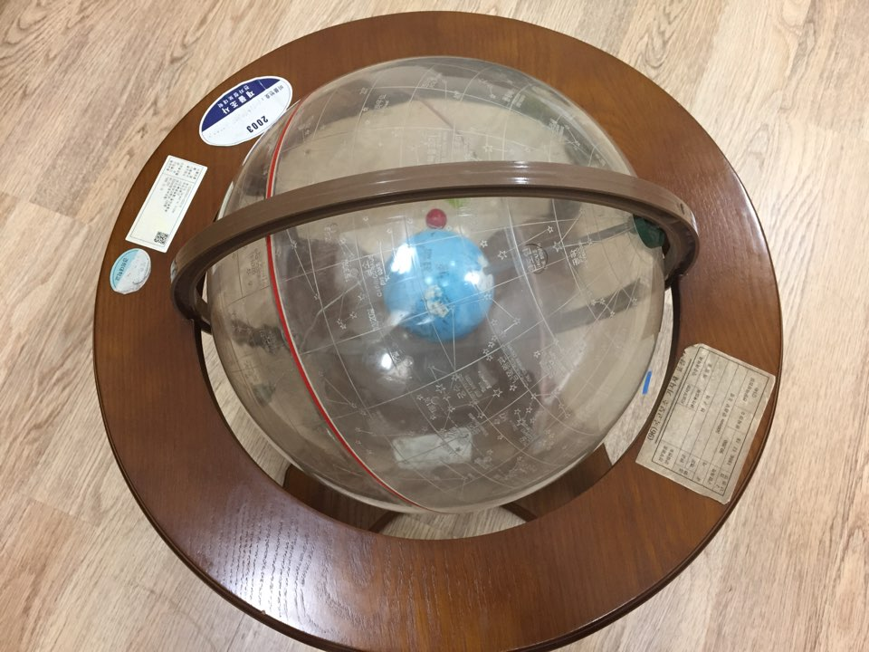

Example 1.15 Sydney

### 2.2. Earth's Rotation

Planet Earth rotates itself. As viewed from the north pole, Earth turns counter clockwise. However, when it is viewed from the south pole, Earth turns clockwise. We can confirm this by rotating our celestial sphere model by our hand. In the heliocentric theory, as the Earth rotates around the axis of itself, **diurnal motion** of stars occurs in a one-day term. Diurnal motion of stars is an astronomical term referring to the apparent motion of celestial objects around the two celestial poles which is looked by a observer in Earth, over the course of one day. so almost every star appears to follow a circular path called the **diurnal circle** when we see the sky. As Earth turns counter clockwise when it’s viewed from the north pole, the diurnal motion of the celestial objects has a same direction; diurnal motion of celestial objects in the northern hemisphere of Earth turns counter clockwise with the Polaris in the center of the diurnal circle. Therefore, like the rotation, the direction of diurnal motion in the southern hemisphere is clockwise.

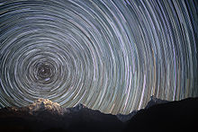

Figure 2.1 diurnal circle in the sky

2. 2.1 Diurnal motion of stars and the sun during a day.

* For our model, to see the diurnal motion of the celestial sphere, we have to fix the Earth by our hand and rotate the model. Despite of the rotating sphere, Earth is stable so we can think as an observer in the Earth and see the movement of stars. You should remember that one rotation of the sphere is one daytime in Earth’s time scale. Actually, there are other ways to count one day precisely which is solar time & sidereal time, but we will not discuss about this now. The accurate time about the solar time & sidereal time would be considered at next section, at 2.4 time.
* In addition, you should make rotation of the celestial sphere when the sun is at the vernal equinox, autumnal equinox, summer solstice, winter solstice. Think about the relationship with the seasonal changes of Earth and where Sun is located.
* 
* 2.2.2 Diurnal motion for various locations
* Then, what happens to the celestial sphere if the location of the observer in Earth changes?
* Check out This for these locations : North pole, south pole, equator, Suwon, Sydney.



Example 1.16 North pole



Example 1.17 Equator



Example 1.18 South pole



Example 1.19 Sydney



Example 1.20 Suwon

* Ref : <https://en.wikipedia.org/wiki/Earth%27s_rotation>

### 2.3. Revolution of the Earth

* 2.3.1 The positions of the sun during a year.
* The position of the sun in the celestial sphere changes due to the revolution of the Earth. The revolution of the Earth is a phenomenon that is originated from the sun’s strong gravity pulling Earth. In the celestial sphere, sun moves slowly but daily and come back to the first location after one year. We call the circle that sun passes upon the celestial sphere **ecliptic circle**, and the **ecliptic** is the mean plane in the sky that the Sun follows over the course of a year, and it is the basis of the ecliptic coordinate system. Let’s consider about the direction of the revolution. From a vantage point above the north pole of either the Sun or Earth, Earth would appear to revolve in a counter clockwise direction around the Sun. In the celestial sphere, this is the opposite direction of the diurnal motion of other stars.
* There are four important points on the ecliptic, which we have found at 2.1. It is vernal equinox, summer solstice, autumnal equinox, winter solstice. The vernal equinox and autumnal equinox are points that the equator of the celestial sphere and the ecliptic meets, and the summer solstice and the winter solstice are the points appear to reach their most northerly or southerly excursion relative to the celestial equator.

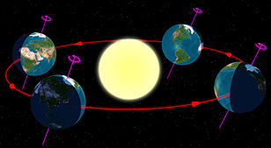

Figure 2.2 Revolution of the Earth

* 2.3.2 The diurnal motion of the sun during a day.

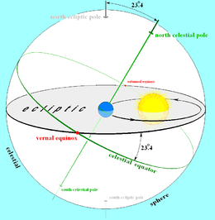

Figure 2.4 Sun’s location on the celestial sphere

The diurnal motion of the sun during the day is in a different circle upon the celestial sphere every day due to Earth’s revolution. If we think that one year is 365 days approximately, Earth has a circular orbit centered with sun. So we can calculate that Sun moves almost 1 degree on the celestial sphere in one day term. Actually, Earth is rotating and making the revolution on the sun, which is quite complicated as the combination of diurnal motion and movement of sun occurs at the same time. So the location of the Sun upon the ecliptic causes seasonal changes in Earth because the highest altitude and the duration of Sun is highest at Summer solstice, and lowest at winter solstice (at northern hemisphere, and this is opposite in southern hemisphere).

* 2.3.3 The difference between the solar time and the sidereal time.

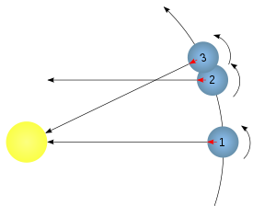

Figure 2.5 Movement of Earth during one solar day and one sidereal day

* In Earth, the sidereal day is shorter than the solar day. At time 1, let’s think about a certain distant star that could be on the line going through both Sun and Earth. At time 2, the planet has rotated 360° and the distant star is at the same location in the celestial sphere to the observer in Earth(1→2 = one sidereal day). But it is not until a little later, at time 3, that the Sun is at the same location in the celestial sphere because of Earth’s revolution(1→3 = one solar day). More simply, 1-2 is a complete rotation of earth ,but because the revolution around the Sun affects the angle at which the Sun is seen from the Earth, 1-3 is a time to watch sun being located at the meridian circle again. Think as one person is standing on the Earth. This maybe help your understanding.

Ref : 1) <https://en.wikipedia.org/wiki/Earth%27s_orbit>

2) <https://en.wikipedia.org/wiki/Ecliptic>

3) <https://en.wikipedia.org/wiki/Solar_time>

### 2.4. Time

* 2.4.1 Definition of Solar Time

**Solar time** is measured by the apparent diurnal motion of the Sun, and local noon in apparent solar time is the moment when the Sun is exactly due south or north (depending on the observer's latitude and the season). A mean solar day (what we normally measure as a "day") is the average time between local solar noons.

* 2.4.2 Definition of Sidereal Time
* **Sidereal time** is a "time scale that is based on Earth’s rate of rotation measured relative to the fixed star from a given observation point, a star found at one location in the sky will be found at the same location on another night at the same sidereal time.
* 2.4.3 One solar day in V.E.(Vernal equinox) and S.S.(Summer solstice)
* Without thinking any effect of gravity or Kepler’s law, Sun moves faster at the V.E, because of the Earth's rotation axis is tilted and the Sun moves approximately 1 degrees in the celestial sphere in one day. Due to the tilted axis of Earth, the ecliptic is tilted to Earth's celestial equator (tilted about 23.5 degrees). When the Sun goes by the equator at both vernal and autumnal equinoxes, the Sun moves approximately 1 degrees in the celestial sphere, while other stars don’t move that much, and there is a angle between the direction of sun and the equator. Specifically, The daily rotation of stars are rotating by the axis of the earth. However, sun can be one of those stars in one day. Then, think about the position of the sun at each V.E, S.S, A.E, and w.S. the V.E, and A.E will have same circle with same radius in the celestial sphere. But at the S.S and W.S, the circle has a smaller radius than the equinoxes in the celestial sphere as they are at the higher declination (D.A). Think about a string covering a soccer ball. At the equator of the soccer ball, the radius of the circle made by the string is the maximum it can have. As it goes higher or lower maintaining the center of the circle at the axis of the soccer ball, the radius decreases. So the time of the rotation should be shorter than the equinox. We can confirm this under this table of the length of apparent solar day in 1998.

|  |  |
| --- | --- |
| **Date** | **Duration in mean solar time** |
| February 11 | 24 hours |
| March 26 | 24 hours − 18.1 seconds |
| May 14 | 24 hours |
| June 19 | 24 hours + 13.1 seconds |
| July 25/26 | 24 hours |
| September 16 | 24 hours − 21.3 seconds |
| November 2/3 | 24 hours |
| December 22 | 24 hours + 29.9 seconds |

**Length of apparent solar day (1998)**

Ref : 1) <https://en.wikipedia.org/wiki/Sidereal_time>

2) <https://en.wikipedia.org/wiki/Solar_time>

## 

## 3. Celestial Coordinate System

### 3.1. Horizontal System

* TBD

### 3.2. Equatorial System

* TBD

### 3.4. Converting Coordinates

## 4. Suggestions (option)

* You can also write any episode or suggestions for the future class.

# Project 02. Kyung Hee Astronomical Observatory

## 1. Introduction

* What is your assignment in this project?

The main assignment in this project is to learn about the facilities of Kyung Hee Astronomical Observatory and understand the process of observation. Then, by making a manual for the observation process, this manual should be used for my observation project and also for students who will do observation in KHAO after me. As Kyung Hee Astronomical Observatory has observed a variety of celestial objects for research since 1992, it has a long history of observation. Therefore, knowing about the facilities and understanding how do they work will be quite helpful to develop individual observation knowledge.

* What is the background theory?

There are three important theories to understand the observation process. It is 1) the CCD camera, 2) the celestial sphere and the mount, 3) the focusing process. Actually, each of these theories are responded with the programs for observation which are Maxim DL, The Sky X, and the Microtouch.

1. The CCD camera

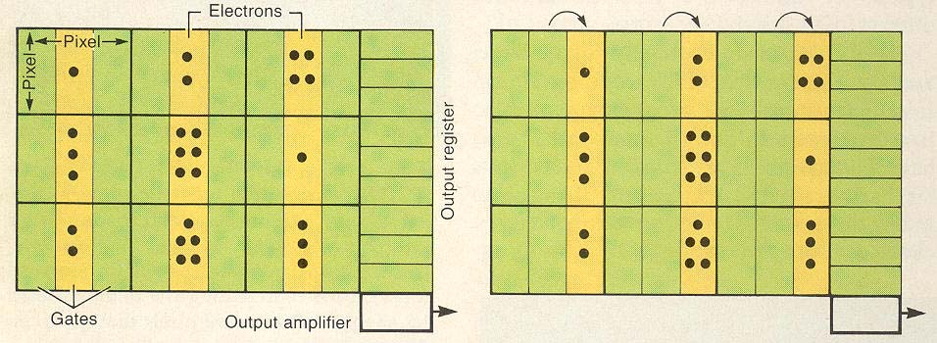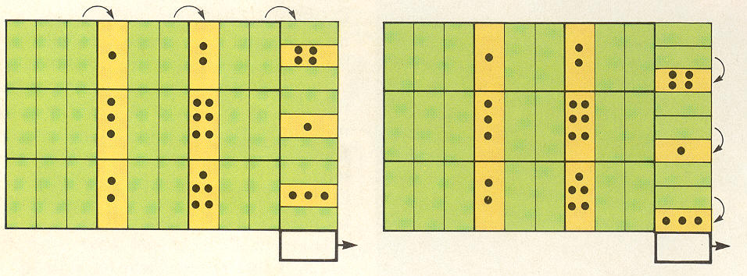

Figure 1.1 Process of CCD camera

The CCD camera is composed with a surface made by light-sensitive silicon diode, and it is formed with rectangles arrayed with 1 pixel area squares. The principle of the CCD camera is this; In figure 1.1, as the light from the telescope comes to the detector of the CCD, the photon hits the surface of the detector, then the electrons jump out from the diode and they are locked up in the pixel because of the **photoelectric effect**. After the exposure, the stockpiled electrons on each pixel are delivered to the readout buffer following the detector’s row by changing the difference of electric potential between pixels. The electrons in the readout buffer are delivered to the analog/digital converter, so the converted digital value of the electron is transmitted to the computer. Then we can have the digital image of the object.

Ref : <http://astro.kias.re.kr/~hshwang/ccd.html>

1. The celestial sphere and the mount

The movement of the telescope and the dome is closely related with tracking the celestial object. So you have to understand about the celestial sphere and how the object will move during the observation. This is also related with the mount of a telescope. The possibility of tracking objects depends on which mount the telescope is using, so you have to know about it.

For our telescope, our mount type is equatorial. An **equatorial mount** is a mount for instruments that compensates for Earth’s rotation by having one rotational axis parallel to the Earth's axis of rotation. Additionally, The **Open Fork** mount has a *Fork* attached to a right ascension axis at its base. The telescope is attached to two pivot points at the other end of the fork so it can swing in declination. So this is the reason why our mount and dome of Kyung Hee Astronomical Observatory is heading north.

Ref : <https://en.wikipedia.org/wiki/Equatorial_mount>

1. The focusing process of Cassegrain telescope

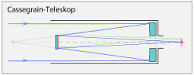

Figure 1.2 focusing of Cassegrain telescope

The **Cassegrain telescope** has a parabolic primary mirror, and a hyperbolic secondary mirror that reflects the light back down through a hole in the primary. Folding and diverging effect of the secondary mirror creates a telescope with a long focal length while having a short tube length. For telescopes built to the Cassegrain design, the image is formed behind the primary mirror, at the focal point of the secondary mirror. An observer views through the rear of the telescope, or a CCD camera or other instrument is mounted on the rear. For large telescopes with correspondingly large instruments, an instrument at Cassegrain focus must move with the telescope as it slews; this places additional requirements on the strength of the instrument support structure, and potentially limits the movement of the telescope in order to avoid collision with obstacles such as walls or equipment inside the observatory.

So the focusing process is moving the secondary mirror and finding out the proper focal length that we can have a clear image of the celestial object.

Ref : <https://en.wikipedia.org/wiki/Reflecting_telescope#Cassegrain_focus>

## 2. Observatory Facilities

## 2.1 Telescope

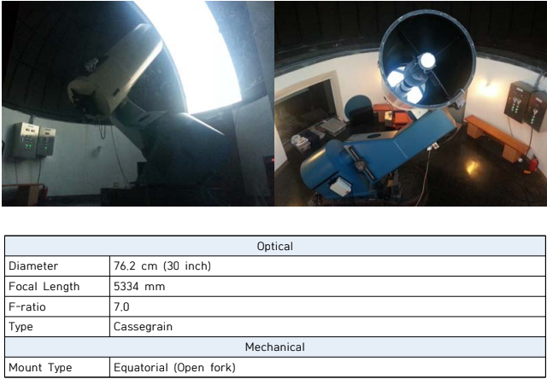

Picture 2.1 Kyung Hee Astronomical Observatory reflection telescope

### 

### 2.2 CCD camera

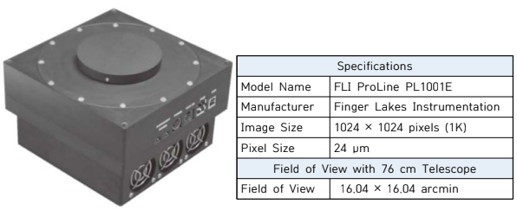

Picture 2.2 Kyung Hee Astronomical Observatory CCD camera

### 

### 2.3 UBVRI filter

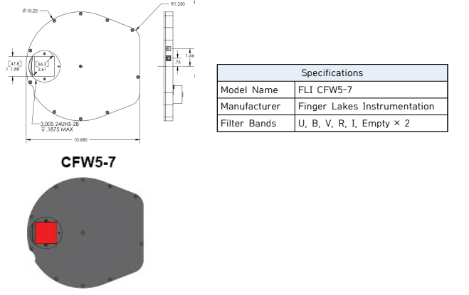

Picture 2.3 Kyung Hee Astronomical Observatory UBVRI filter

### 2.4 Dome activating facility

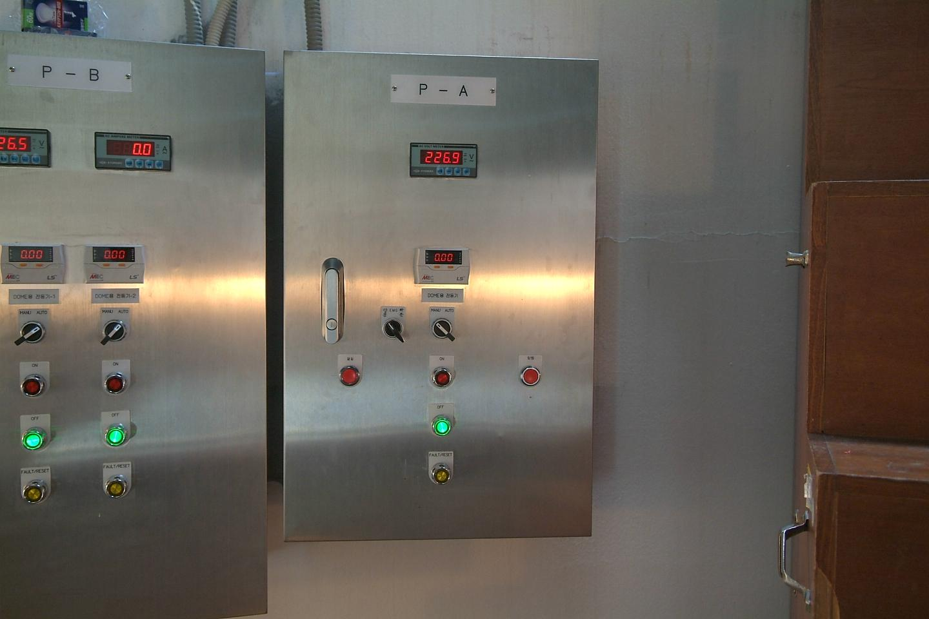

Picture 2.4 Dome activating facility

### 2.4 Main Computer

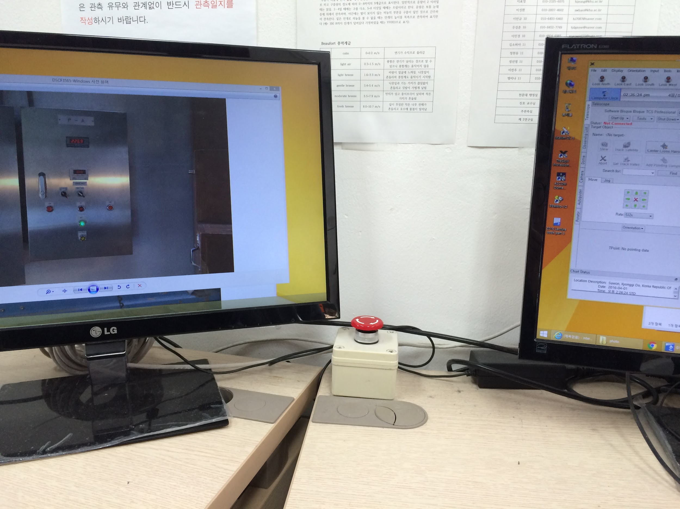

Picture 2.5 Main computer

Ref : <https://drive.google.com/drive/folders/1kcCGqcbRT328Glc1hfLRYdtEw5fe_FfL>

## 3. Observation Process

Now this is the observation process manual. Please follow this manual on your observation.

### 3.1 Before observation

Before observation, you have to write the **observation journal** and the **Log book.** You can print this at the website or there are some copies in the observatory, and you can use the printer next to the main computer. This is essential because leaving the data of observation is very important for the research and also for the administrator of the observatory.

3.1.1 Log book



Picture 3.1 Log book

Words in the Log book

Instruments : Kyung Hee Astronomical Observatory 76cm reflection telescope, CCD( FLI ProLine PL 1001E), filter ( FLI CFW5-7) , focuser ( Microtouch)

Weather, Temp, Humidity : Write down from <http://www.kma.go.kr/eng/index.jsp> (Korea Meteorological Administration)

Astronomical Seeing : How spread the image of the star is shown. It is related with the stability of the atmosphere. Measure during observation by Maxim DL and write down.

* You don’t have to write down sec. mirror

File name : Write down the name of image that is saved in the main computer of the observatory.

ex) NGC1021_00001, M87_00002 …

LT : This means Local time, the time you took the picture of the image.

EXP time : How long did you exposed, and the unit is second.

Filter : The filter you used for the object.

Comment : What you felt, or any other comments.

**After finished the Log book, put it at the punch book on the rear desk.**

3.1.2 Observation journal

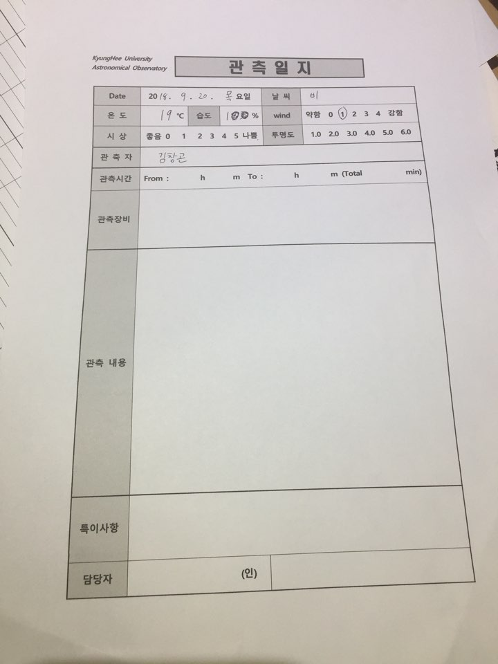

Picture 3.2 observation journal

Words in the observation journal

Weather, Temp, Humidity : Write down from <http://www.kma.go.kr/eng/index.jsp> (Korea Meteorological Administration)

Astronomical Seeing(시상) : How spread the image of the star is shown. It is related with the stability of the atmosphere. Measure during observation by Maxim DL and write down.

Transparency(투명도) : related with the foggy weather of the air, not related with clouds.

Observation time : The time between when the observer opened the dome and when the observer closed the dome; The total time of opening the dome.

Instruments : Kyung Hee Astronomical Observatory 76cm reflection telescope, CCD( FLI ProLine PL 1001E), filter ( FLI CFW5-7) , focuser (Microtouch)

Observation contents : Dome opening time, Observation time, the local time of the object, etc.

Specific details : Problem occurrence, proposing details.

**After finished the Observation journal, put it at the punch book on the rear desk.**

### 3.2 Preparation in Dome

**Before opening the dome you MUST check out the weather and the humidity!**

When the humidity goes over 90%, the interface of the instrument can have some fault and dew can be made in there. So NEVER open the dome when the humidity is over 90% or it is raining.

Going out to the catwalk every 20~30 minutes will be good to check out the weather outside.

If the weather gets bad and the humidity goes higher, you should stop your observation.

3.2.1 Turn on the instruments

1. Turn on the main switch in the main observation room, which is at the back of the main computer. You just have to **turn the switch clockwise and don’t push!** It is better to send only one person to turn on the switch if you are a group.

Picture 3.3 Main switch

1. Then turn on the multi-tab at the floor, next to the telescope.
2. Turn on the silver switch, which is the switch of the focuser (Microtouch). Then you have to see the top side of the telescope and confirm that the red light is flashing.
3. Then turn the red switch which is for the telescope mount in picture 3.4 to activate the telescope. Again, don’t push! 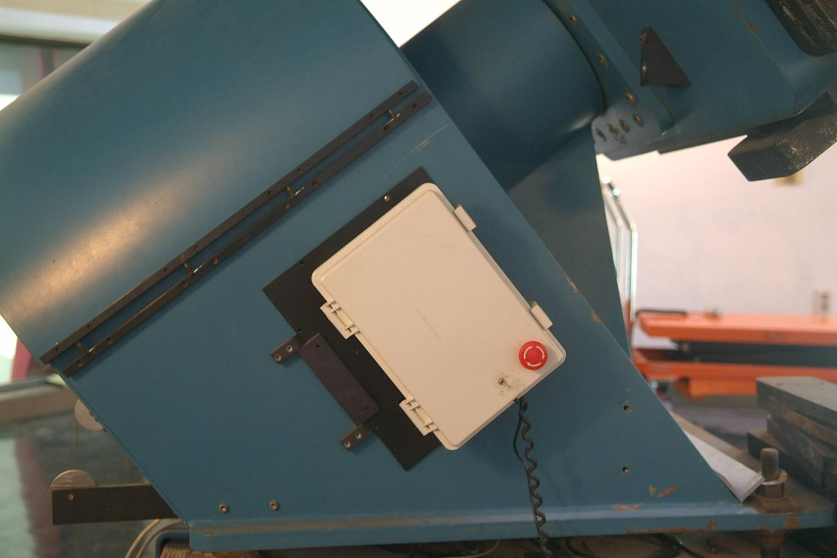 Picture 3.4 Main switch of telescope mount
4. Then you have to move the telescope by the joystick manually to tilt the telescope to the moving stair in the dome and **take off the cover** of the telescope. When you take off the cover, you have to turn it and take off it from the locking part. To do it more safely, some people should hold the stair downstair. For help on activating the joystick, the telescope goes back to the initial state if you press the button upper part of the joystick two times.

3.2.2 Opening the dome

1. The Kyung Hee Astronomical Observatory Dome is composed of upper dome shutter and bottom dome shutter. **And this dome moves manually!**
2. So if we take a look of the P-A dome activating facility which is for opening the dome shutter first, it is like this if you press the on button in the initial state. 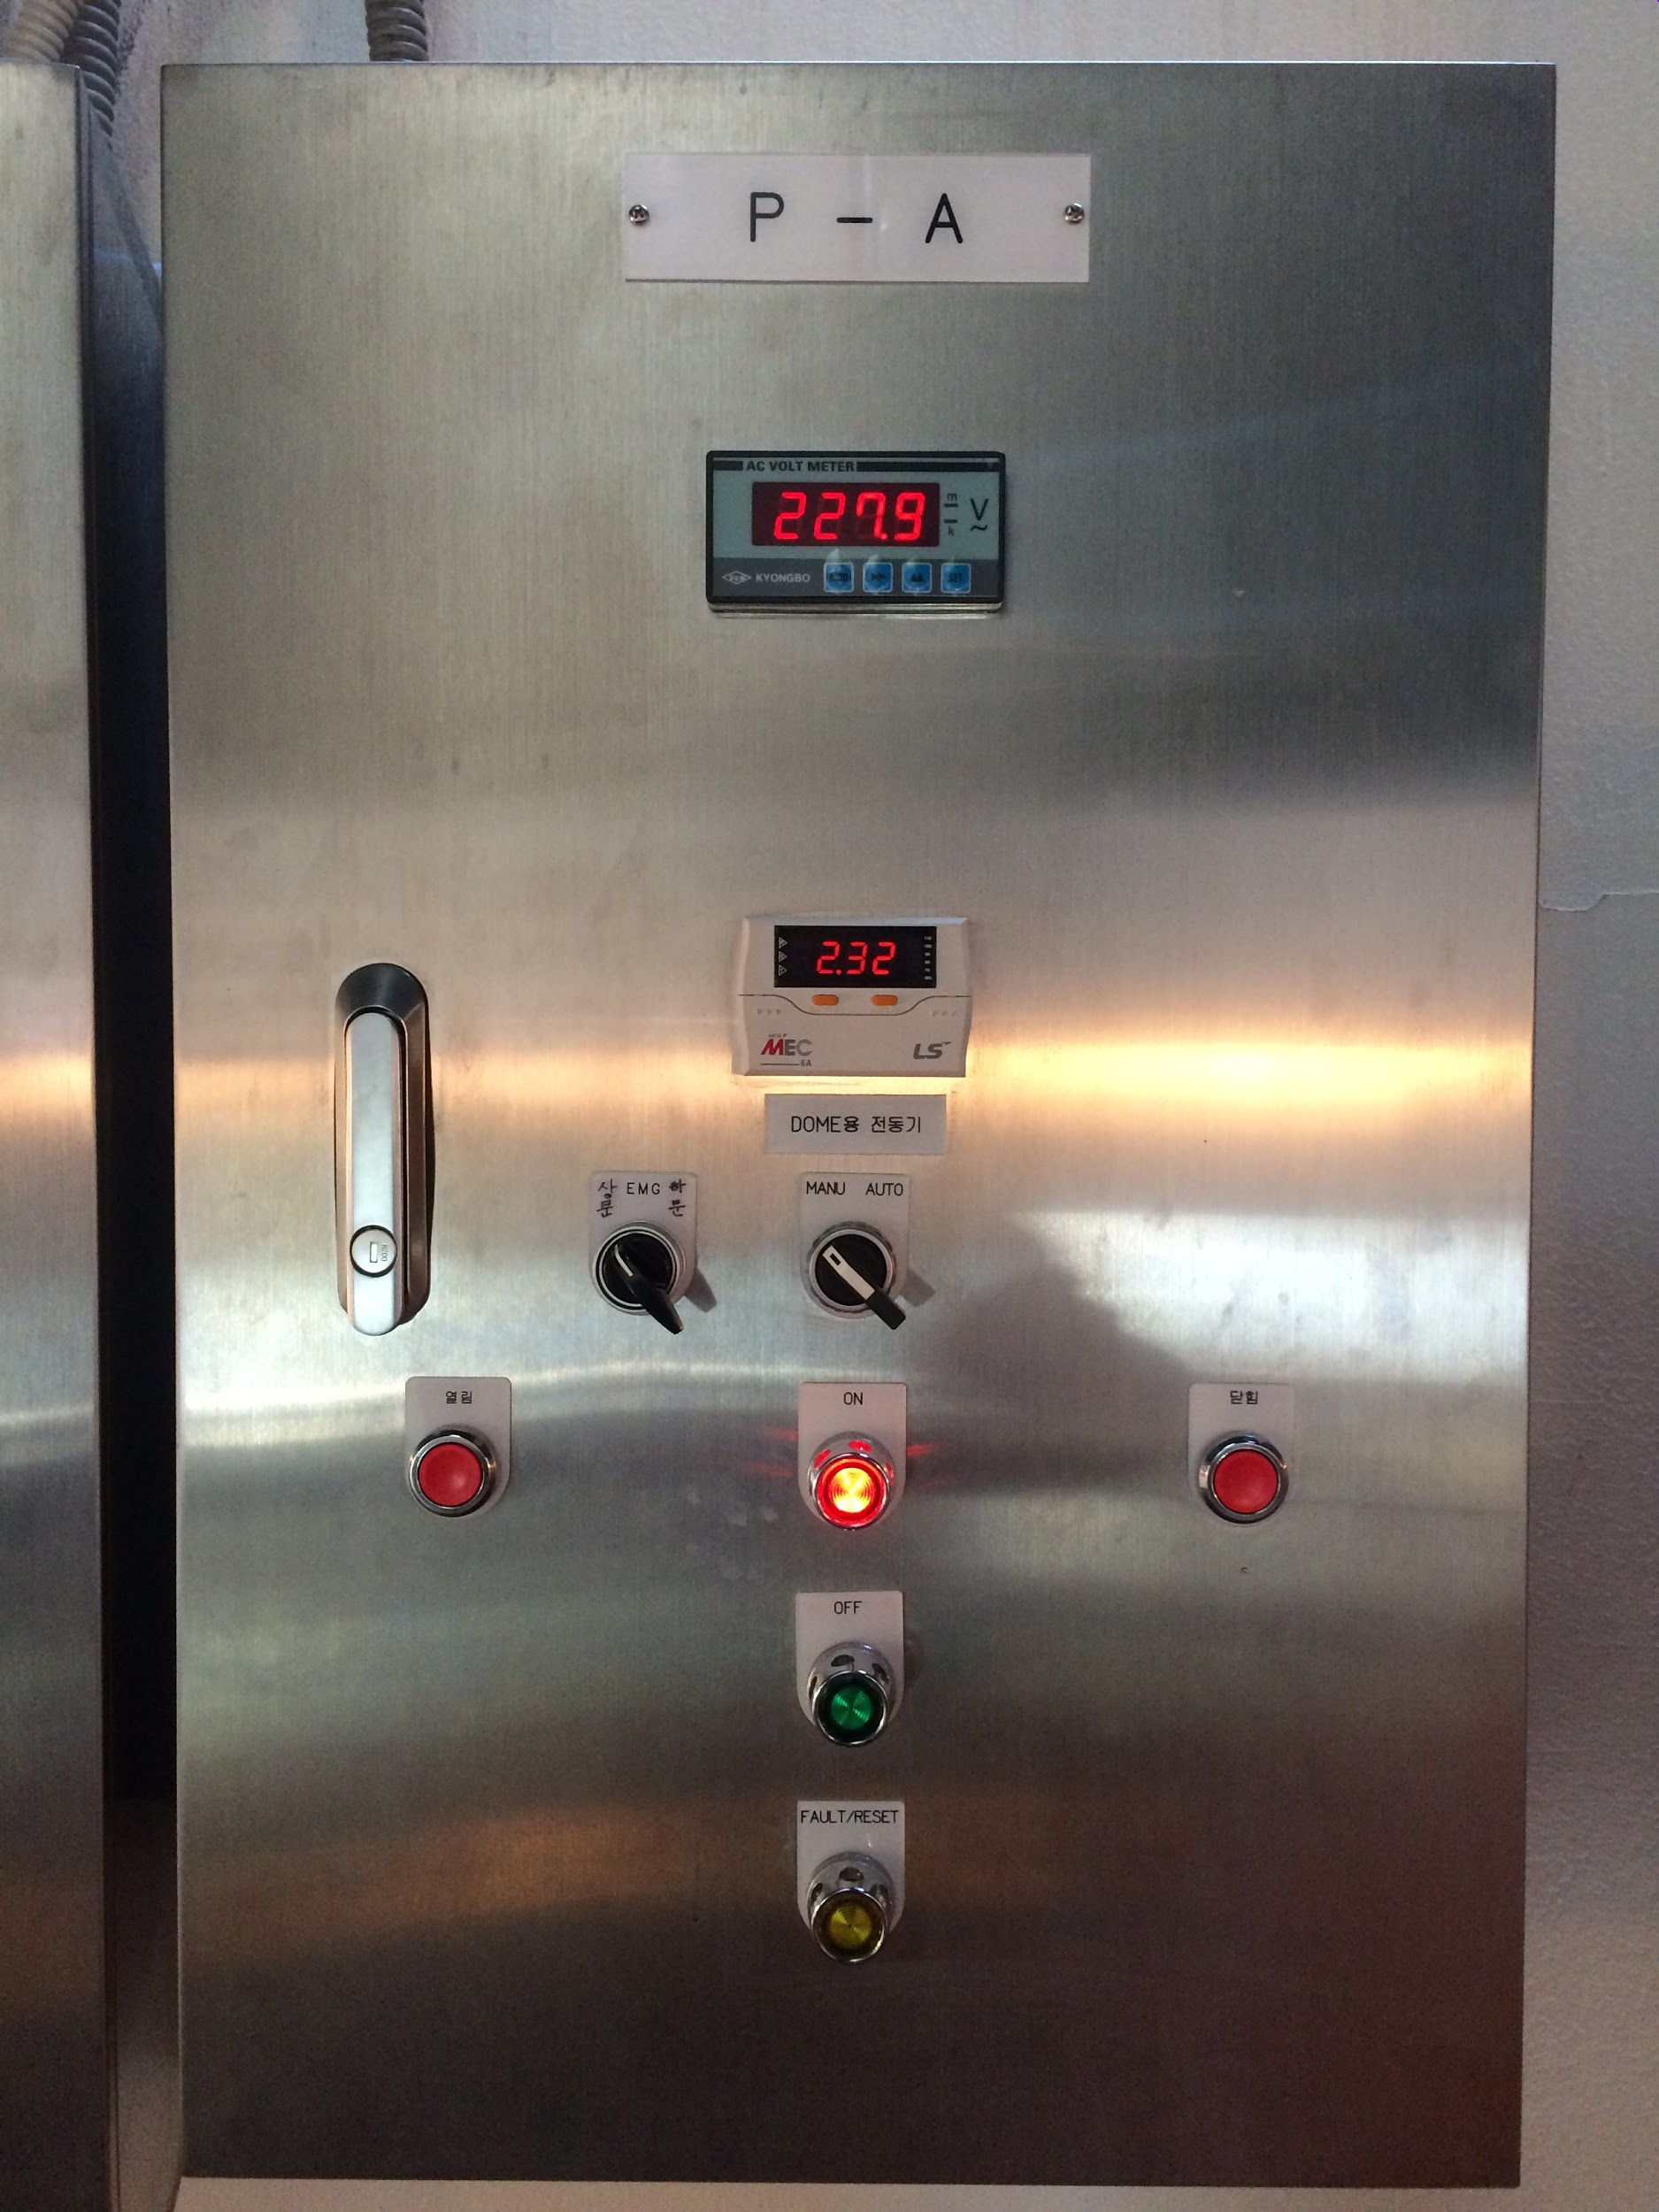 Picture 3.5 P-A dome activating facility

1. First you have to open the upper shutter of the dome. Put the lever like picture 3.6 and press the open button. **This process must be prior to opening the bottom shutter**. The upper shutter opens automatically since you press the button once. 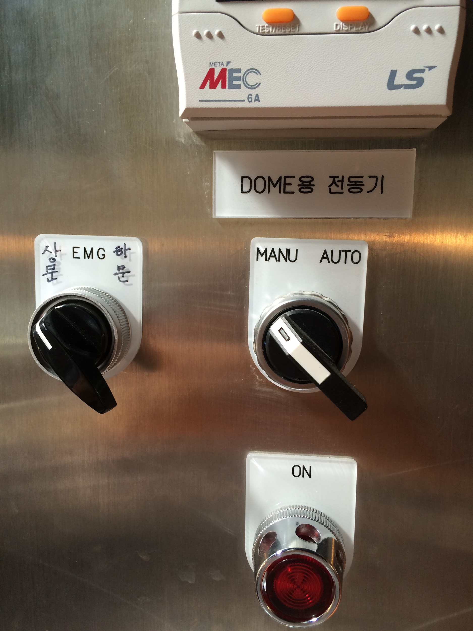 Picture 3.6 EMG lever on the upper shutter
2. Then you have to open the bottom shutter of the dome. Put the lever like picture 3.7 and press the open button. **This process must be next after opening the upper shutter.** For the bottom shutter, you have to keep pressing the open button to open it fully. 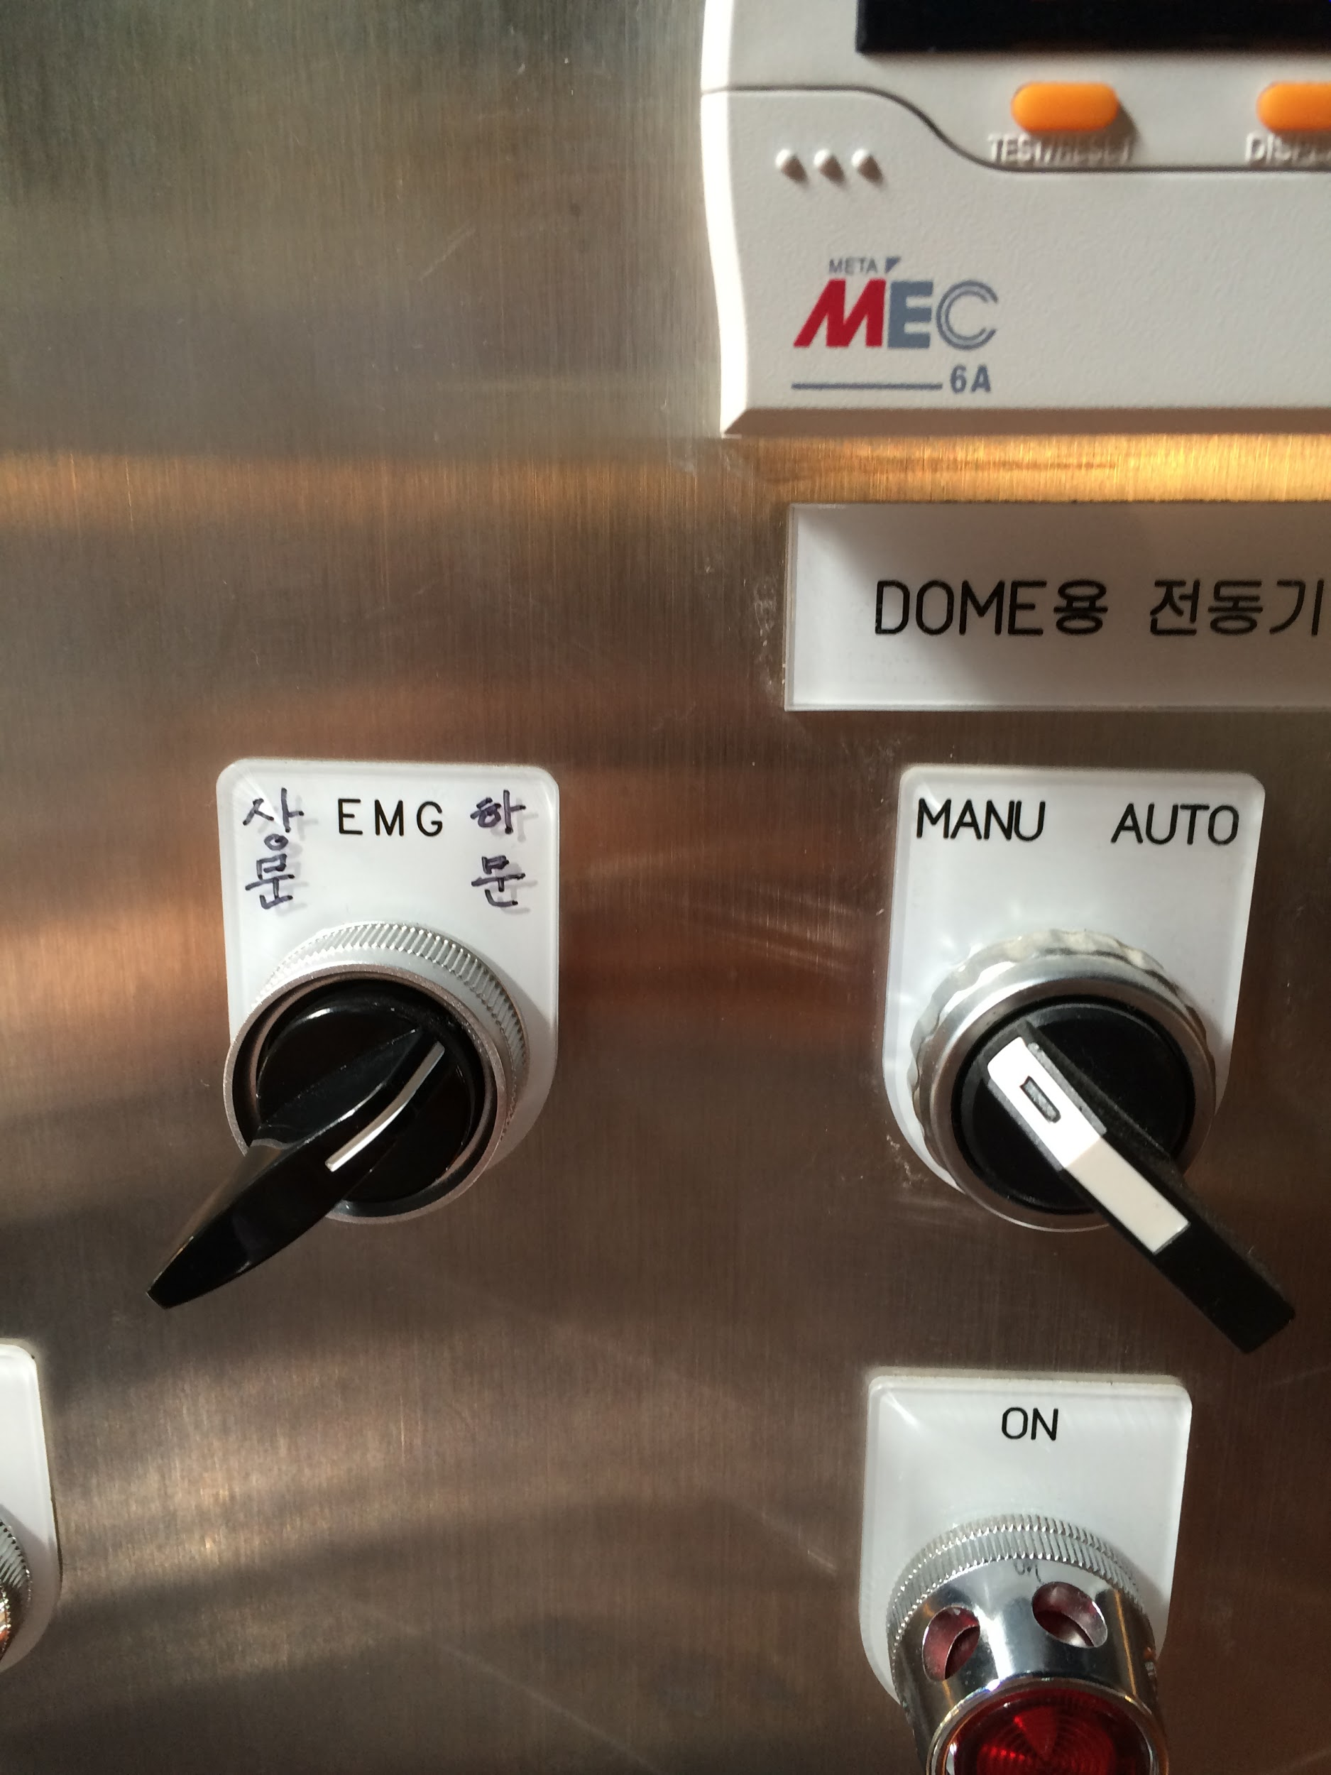 Picture 3.7 EMG lever on the bottom shutter
3. Next, if we take a look of the P-B dome activating facility which is for moving the dome horizontally, it is like this in the initial state. 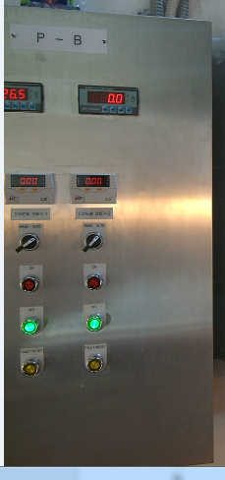 Picture 3.8 P-B dome activating facility
4. If you press the right on button, the dome moves right(clockwise if we see at the top of the observatory) and if you press the left on button, the dome moves left(counter clockwise if we see at the top of the observatory) When you are moving the dorm on a large angle, **you must not go the distance by one time but go by several times with intervals. The dome sometimes get overloaded.** Because this facility moves manually, the observer has to keep coming to the dome during observation and move it to the appropriate location with the telescope. Now, let’s set the dome to the appropriate location for observation.
5. After finishing to move the dome, **you must turn off the light of the main dome!!**
6. Then **you must close the curtain of the room of the main observatory**, where the main computer is located.

### 3.3 Observation by software

First, you have to turn on the desktop of the main computer. **The desktop at the right is the one we have to turn on. Don’t touch the left one.**

3.3.1 Maxim DL 5

1. Double click the Maxim DL icon

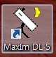

1. Click the camera control



1. This is the camera control window

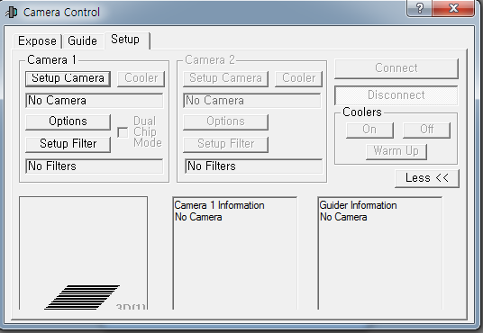

Picture 3.9 Camera control window(this is an example)

Then click the connect button, and the message ‘camera idle cooler is off’ will expose.

1. Next, click the coolers ‘on’ button. If you click the button, the message ‘set point : -30 C

Temperature : (the temperature now) ‘ will expose. When you see this message, you have to wait until the CCD gets cool.

1. Click the ‘expose’ tap in the camera control window.

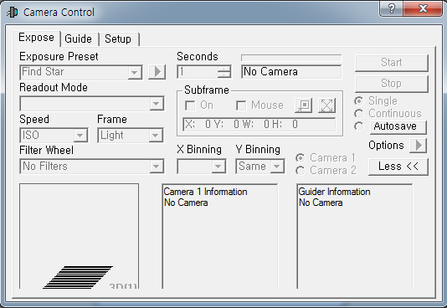

Picture 3.9 Camera control window-exposure tap(this is an example)

1. Then click ‘readout mode’ and put it in to ‘1 MHz High-gain’

This mode is about setting how fast the converter reads the electrons in each pixel of CCD, **but the noise of the image gets bigger if it reads faster.**

1. Next you have to set the frame type by clicking ‘Frame’. You can set Light, Bias, Flat, Dark in this setting.
2. Then you have to set the filter by clicking ‘Filter Wheel’. You can set UBVRI filters in this setting.
3. Next you have to set the exposure time by modulating ‘Seconds’. You can set exposure time by seconds in this setting.
4. Then you have to put ’X binning’ and ‘Y binning’, to 1. The binning means the size of image, so 1 binning is 1024 $×1024$, and 2 binning means 512 $×$ 512, etc.
5. Then at the right side of the window, you can see 3 taps. The ‘single’ , ‘continuous’, ‘autosave’ tap is taps for how to take the image. ‘Single’ means taking only 1 image. ‘Continuous’ means taking image every time interval that you set for exposure until you click stop. ‘Autosave’ means saving the image automatically, and to use this setting, you have to click the tap and save the name of your object at the first space.
6. In the ‘options’ tap, you must confirm if the ‘No Calibration’ is checked. Also, you can set image save path if you click ‘set image save path’ .

The route of saving files on the main computer is this : Cdrive-OBS data- (make a folder with a name of the date that you observe)

3.3.2 Microtouch (focuser)

1. Click the Microtouch icon on the screen.

1. Click connect.

1. Then you can see the range of 0~60000 on the window.

You can put the value you want at the ‘Target position’ and click ‘go to’ then the microtouch will activate. This is how to move the focus length of the telescope. When you put a wrong value, don’t worry and just click stop.

When it is 60000, but you don’t have the appropriate focus, don’t worry.

Follow this process.

First go to 60,000 and write 30,000 on the ‘Target Position’ and click ‘reset’.

Then the 60,000 value goes to 30,000 and you can move the microtouch more.

If you need smaller value, you can do same by putting 0 and resetting it at 30,000.

1. So, how do we focus the telescope?

First, In Maxim DL, if we have a image of star, click ‘target’ like this.



Then you will have a blue target cuser and put it at a star.

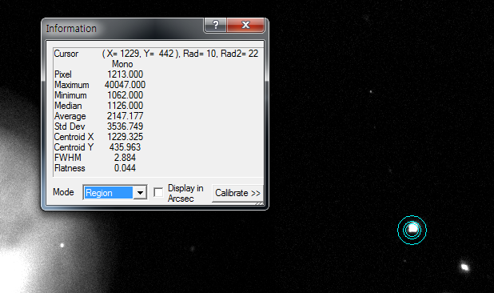

Picture 3.10 Information of star by targeting in Maxim DL

Then take a look of the FWHM value. You have to find the focus when the FWHM value is minimum. For Kyung Hee Astronomical Observatory, the FWHM value is normally 2.5~4.5.

1. So the focusing process is finding out the FWHM after taking pictures of the object and moving the focus by microtouch and repeating this until you have the minimum FWHM value. .

3.3.3 The Sky X

1. Click the ‘The Sky X’ icon. The initial state of the window is like picture 3.11.

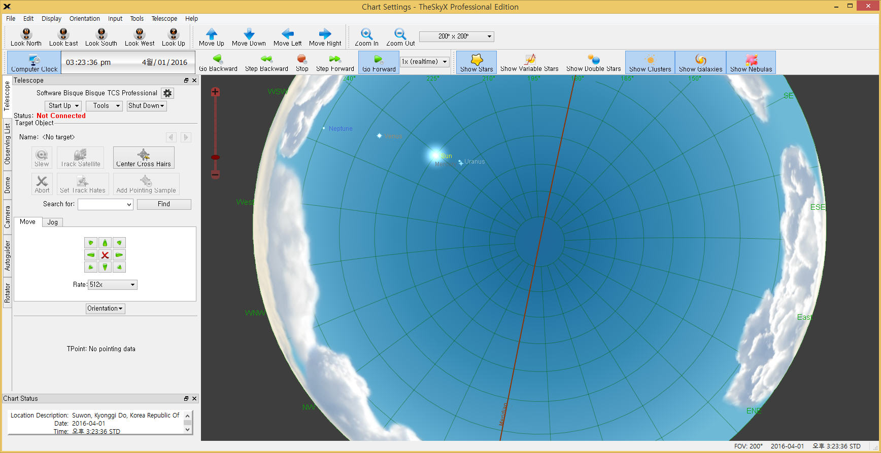

Picture 3.11 The Sky X

1. Click start up and click connect telescope. Then a yellow target circle will expose. This is the direction of the telescope.

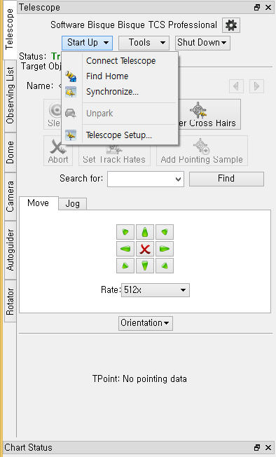

Picture 3.12 Connect telescope

1. If you click ‘find home’ the telescope will come back to initial state.



Picture 3.13 Find home

1. The tracking of the telescope is automatically on process on sidereal rate. So you have to keep check if the object is seeing well, by keep checking the dome and moving the dome.

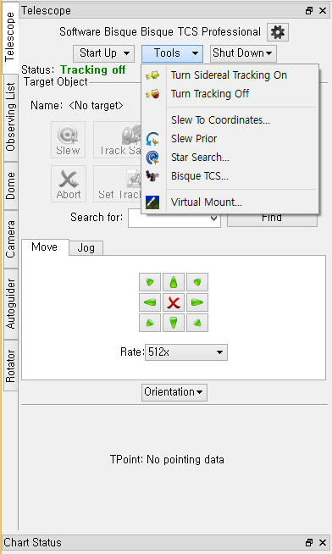

Picture 3.14 Turn sidereal tracking on

1. Then you can see a purple square at the main window. You have to compare this with the Maxim DL image that you have taken. If the location of stars in side the purple square and the image from Maxim DL is different, you have to do ‘synchronize’ process.
2. How to Synchronize the object.
3. Pick one object ( well known stars like Vega, etc.) and put the cursor with red circles at the object and click it.
4. Then, click ‘Slew’ and the telescope will move.

When moving the telescope, you have to move small distance, making intervals on your way because the telescope doesn’t move slightly if it moves long distance in one time.

3) Then compare the purple square image and the Maxim DL image.

4) But repeating this process is too long and hard. SO,

Go to [www.nova.astrometry.net](http://www.nova.astrometry.net) and click ‘upload tap’ and upload your Maxim DL image. Then after waiting a minute, a message of ‘success’ and the information of your image will expose. If you click ‘go to resource page’ you will have the exact information of your image.

Then you just remember the value of the center( R.A, Dec) in the image, and put your red circle cursor at the remembered value of the center (R.A, Dec) in The Sky X, and click synchronize. Check one more time at Maxim DL and it should have a good sync.Then you can start your observation!

3.3.4 Ending observation

1. To turn off the maxim DL, first click ‘off’ of the cooler.

1. **Next, you must click ‘disconnect’ after the cooler is off!!!!!**

1. Close the Maxim DL.
2. Click ‘disconnect’ of the microtouch and close the program.
3. Send the telescope to initial state by clicking ‘home’ in The Sky X.
4. Turn off the tracking.



Picture 3.15 Turn tracking off

1. Click ‘disconnect’ of The Sky X and close the program.
2. **Download the data in your own USB.**

1. Turn off the desktop.

1. Close the cover of the telescope by moving it manually with the joystick.
2. **Close the bottom shutter of the dome first and close the upper shutter next.**
3. Make the telescope go to the initial state by pressing the upper button of the joystick two times.
4. Turn off the focuser, telescope, and the multi-tap.

1. Make the dome go back to head the north and make the stair at the initial state too.

1. Turn off the main switch in the main observatory room, which is back at the main computer.

Just press it!

1. Open the curtain and open the door of the main observatory room.

1. Lock the dome. Turn off the light inside the dome.

# Project 03. Observation

## 1. Introduction

* What is your assignment in this project?

The assignment in this project is to prepare the observation by selecting your target. When selecting your target, you have to validify if the target is appropriate to observe on your observing conditions. First, you have to consider if the target is available to observe by our telescope. Then you have to consider the equatorial coordinate system such as R.A, Dec of your target which is important for knowing when the target will show up in the sky. Moreover, the R.A and Dec will determine the altitude and azimuth angle on the sky during the time you are going to observe. After selecting the target expecting plenty of time to observe, you have to calculate the Air mass of the target by celestial sphere model, google spreadsheet calculation, and web calculation precisely. Then we are going to compare it with each other. After comparing the Air mass, you will start your own observation. You will have your own Flat, Dark, Bias images, which would be used on the data reduction. Next, you will have the image of your target if you determined an appropriate time for observation. However, this is not an easy process, which could need many trials to have the best data.

## 2. Target Selection

* What kind of target do you select?

My target is NGC 7086, an open cluster. This is the physical information of NGC 7086.

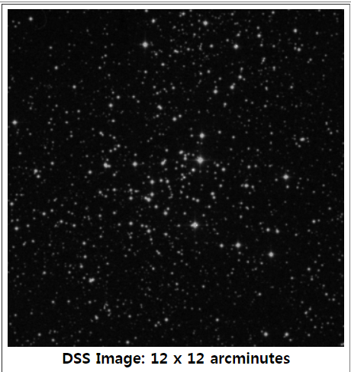

Picture 2.1 NGC 7086

Right Ascension : 21 h 30 m 27 s Declination : +51° 36′ 00″

Galactic longitude : 94.407 Galactic latitude : 0.220

Distance(pc) : 1298 Reddening (mag) : 0.807

Distance modulus(mag) : 13.07 Log Age : 8.142

Radial velocity/ redshift : v(km/s) -19.0km / z -0.000063

Fluxes : B- 9.25, V- 8.4

Abundance of stars: ~210 stars

Ref: A.L Tadross , “Kinematical Focus on NGC 7086” , 2005.

<http://articles.adsabs.harvard.edu/cgi-bin/nph-iarticle_query?2005JKAS...38..423T&amp;data_type=PDF_HIGH&amp;whole_paper=YES&amp;type=PRINTER&amp;filetype=.pdf>

Ref : <http://simbad.u-strasbg.fr/simbad/sim-id?Ident=NGC%207086#lab_notes>

This is the H-R diagram of NGC 7086.

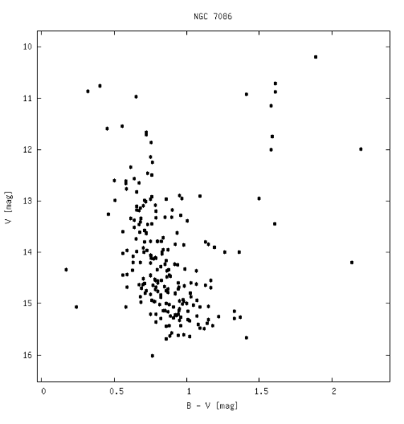

Picture 2.2 H-R diagram sample of NGC 7086

Ref : WEBDA : Diagram

<https://www.univie.ac.at/webda/cgi-bin/plot_cmd.cgi?ngc7086+NGC+7086>

The goal of the observation class this semester is observing this target and drawing my own H-R diagram by the data I have received from observation. Open clusters are interesting and also important celestial objects because it gives us many information of the evolution of the stars. We know that this open cluster is quite old because we can see some stars getting out from the main sequence. Also, if we can know the absolute magnitude of the cluster by photometry, we can know the modulus of distance to the cluster, and we can know the distance by the pogson equation. So, this target would be a great experience to study and observe about open clusters.

## 3. Target Visibility

* Calculate Air mass of your target.

3.1 Celestial Sphere Model

By using the celestial sphere model, I marked the location of my target at the model and tried to find out the (Alt, Az) of my target when the day I’m expecting to have observation. I estimated the (Alt, Az) of NGC 7086 at 21:00.

The altitude was about 80°, and the azimuth angle was about 350°(approximately 23h by time angle). So approximately, by calculation using secZ, the air mass by celestial model is

1.0154.

(update) I had wrong data from the first observation, so I observed my target at 2018.11.13. At this time, using the celestial sphere, the altitude was about 70°, and the azimuth angle was about 330°. So approximately, by calculation using secZ, the air mass by celestial model was 1.0641.

3.2 SpreadSheets Calculation

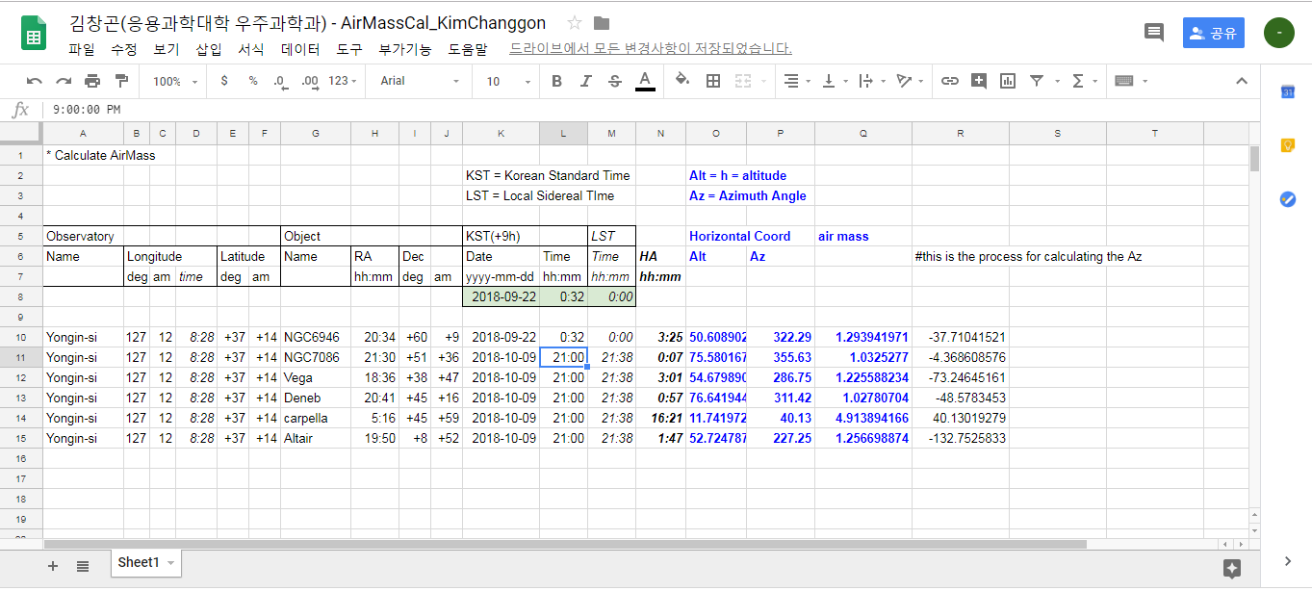

Picture 3.1 Spreadsheet calculation

For calculation, I just used two simple formulas on spherical trigonometry which is

$cosa=cosAsinBsinC +cosBcosC$ (1)

$\frac{sina}{sinA}$ = $\frac{sinb}{sinB}=\frac{sinc}{sinC}$ (2)

Then I converted the equatorial coordinates to the horizontal coordinates. The exact calculation is attached in the spreadsheet, so for reference, check out the spreadsheet. Also, I have tried my spreadsheet for other famous objects such as Vega, Altair, Deneb, ..etc.

This is my spread sheet data : <https://docs.google.com/spreadsheets/d/1p6Ob9ZdQR-sN5Zyg37GCxsWfBrIEeqQ1LwcLfs-cSyU/edit#gid=0>

Additionally, I made a plot of Air mass vs. Hour Angle (between -4h to 4h).

For 2018.11.13, I made an another plot of air mass vs. hour angle of NGC 7086.

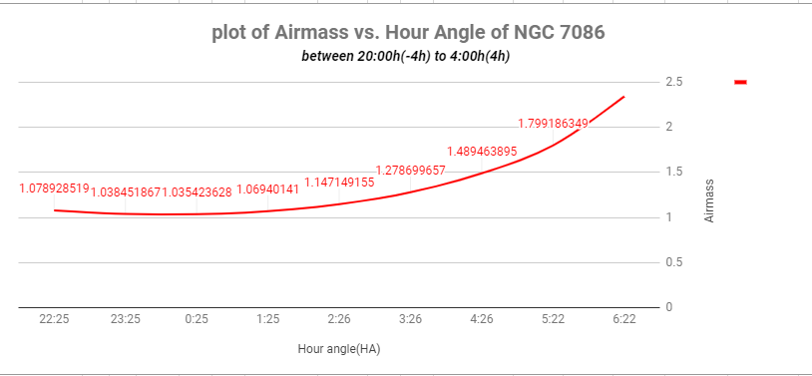

Picture 3.2 plot of air mass vs. hour angle of NGC 7086 in 2018-11-13

3.3 Web Calculation

* For web calculation, I used this web site. Ref: <https://astro.swarthmore.edu/airmass.cgi>
* (update) I changed the date. This is the data from web. I used the Time in zone Australia/Brisbane because the website didn’t have KST. The time zone only has 1 hour difference with KST, so I decided that it will not have that big difference with KST.

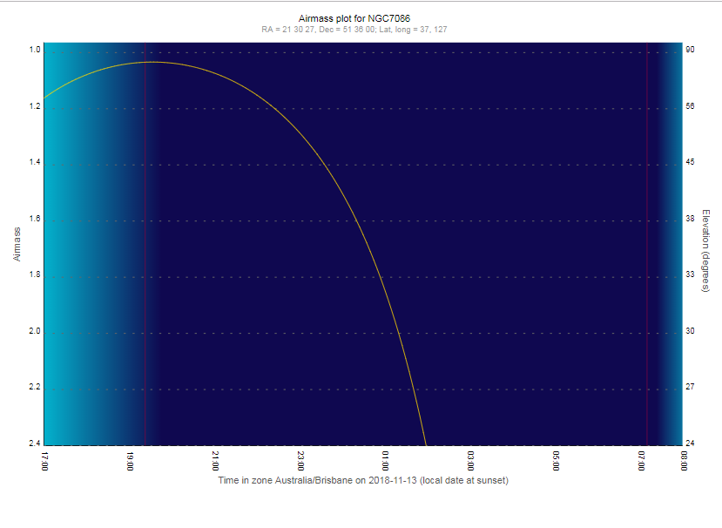

Picture 3.3 Air mass calculation by web

3.4 Comparing Air mass Calculations

* Let’s compare the results. For the celestial sphere model, at 20:00 in November 13th, the altitude was about 70°, and the azimuth angle was about 330°. Approximately, by calculation using secZ, the air mass by celestial model was 1.0641.
* Next, for the spreadsheet calculation,
* At 20:00 in November 13th, the calculated altitude was 69.24°, and the azimuth angle was 320.56°. And the air mass was 1.0694. Also, to confirm the coordinates of my spreadsheet, I used the Stellarium program. This is the data from stellarium.

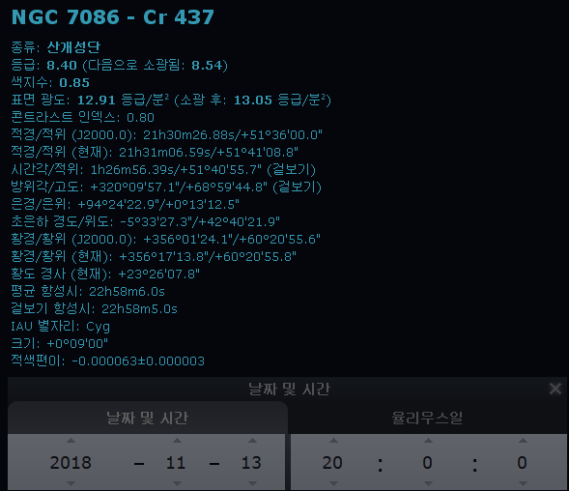

Picture 3.4 Stellarium info of NGC 7086

* Finally, for the web calculation,
* The air mass calculation was like Picture 3.3, which had the value of air mass as 1.03 during 19:20- 19:45, which was the minimum, and 1.04 during 19:50-20:20 in 2018-11-13.
* For conclusion, there were some difference of the altitude and the azimuth angle between the celestial sphere model and the spreadsheet calculation, but it was quite similar. However, the air mass was almost same on comparison of web calculation and my google sheet airmass calculator. To make my spreadsheet more precise, I should use the accurate equation of the air mass such as this equation.
* 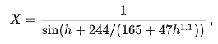

## 

## 4. Observing Log

4.1 Observation conditions

|  |  |  |  |
| --- | --- | --- | --- |
| Observers: Kim chang gon, Kim seoun ho, No ji hoon | | | Date: 2018-11-13(Tuesday) |
| Observing time: 17:30 - 21:00 (KST) | | | Weather : little bit cloudy |
| Seeing : 2.8~3.2 (FWHM) | | | Humidity : 30% |
| Instruments : 76cm Cassegrain telescope (KHAO), FLI ProLine PL1001E CCD camera,  FLI CFW5-7 UBVRI filter. | | | |

4.2 Data of Bias,Dark, Flat

4.2.1 Data of Flat

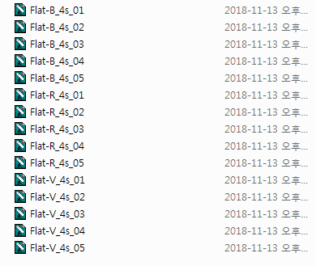

Picture 4.1 Data of Flat

With 4 seconds of exposure, we took 5 images of flat for each B, V, R filter.

4.2.2 Data of Bias

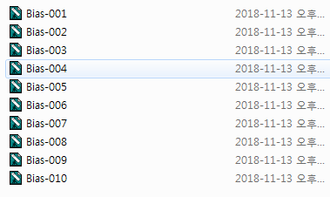

Picture 4.2 Data of Bias

We took 10 images of Bias.

4.2.3 Data of Dark

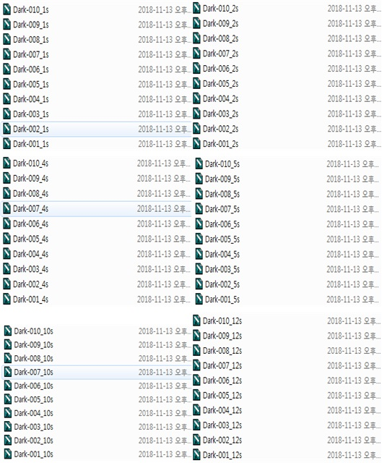

Picture 4.3 Data of Dark

We took 10 images for each exposing time such as 1s, 2s, 4s, 5s, 10s, and 12s(s means second). We had to do this because each targets of the observers needed different exposing time due to their characteristics.

## 5. Sample image

* This is the sample image of NGC 7086, observed in 2018-11-13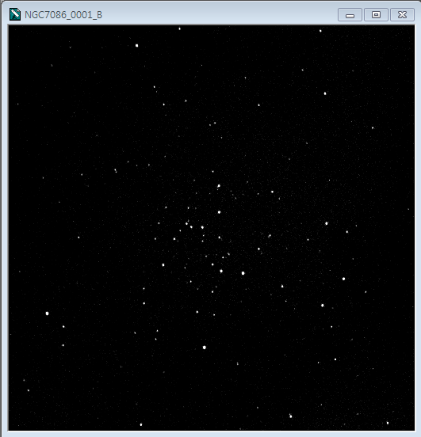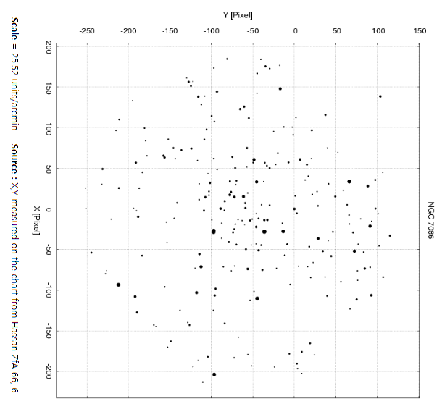

Picture 5.1 NGC 7086 by B filter

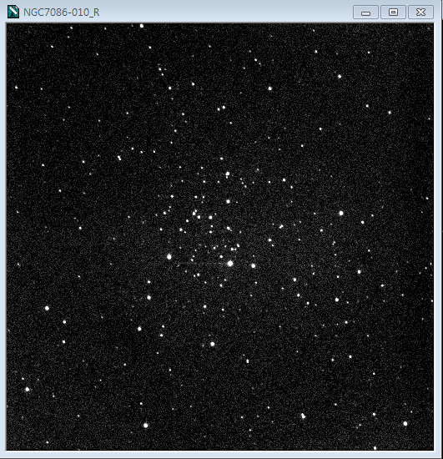

Picture 5.2 NGC 7086 by R filter

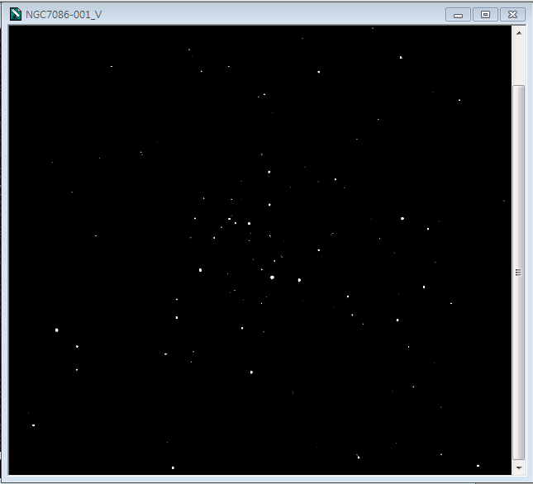

Picture 5.3 NGC 7086 by V filter

Finding chart Ref : <https://www.univie.ac.at/webda/cgi-bin/chart_frame.cgi?ngc7086>

# 

# 

# Project 04. Data Reduction and Photometry

## 1. Data information

* Write the number of bias, dark, flat, and object images respectively for the demo data to practice data reduction and photometry. You can have the data from <https://drive.google.com/file/d/0B8JZAzPSk_AWM0NMZWptME9lUmc/view> .

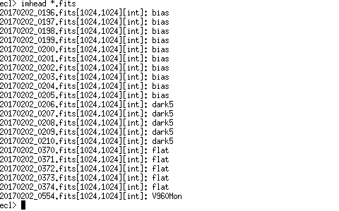

Image 1.1 List of bias, dark, flat, and object images

There are 10 images of bias, 5 images of dark, 5 images of flat, and 1 image of the object for the demo data of V960Mon, which was observed at 2017/02/02.

* What filter was used in demo data?

The information of the filter used in the observation could be found by the ‘imhead (imagename) l+’ command in Iraf. The filter used in demo data was R filter for the object and flat, and B filter for the Bias and Dark. Generally, we don’t have to know about the filter of the Dark and Bias but there are filter information of those from the demo data. You can confirm this by image 1.2, 1.3, 1.4, and 1.5.

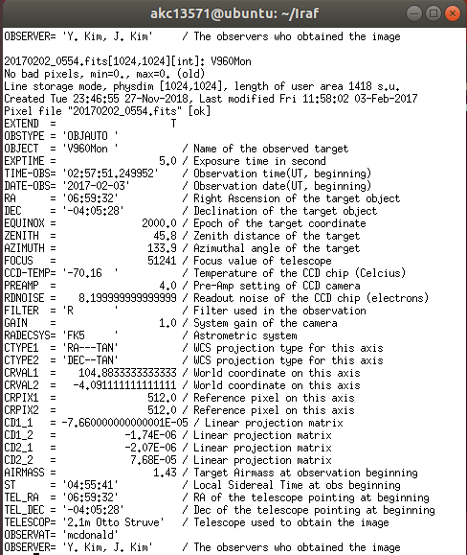

Image 1.2 The information of 20170202_0554 (Object)

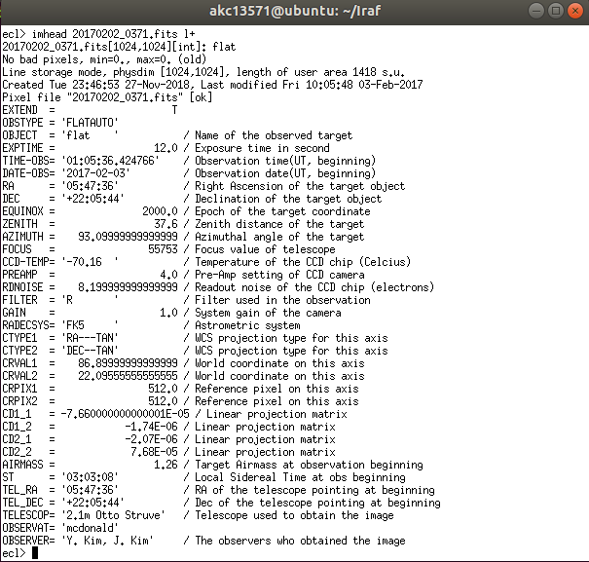

Image 1.3 The information of 20170202_0371 (Flat)

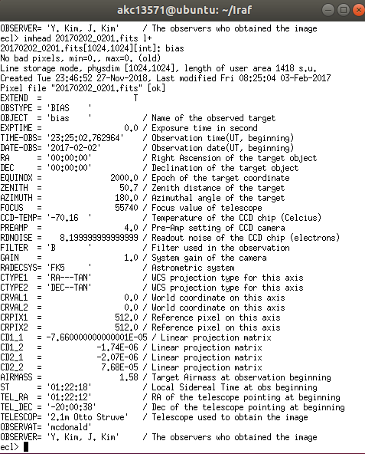

Image 1.4 The information of 20170202_0201 (Bias)

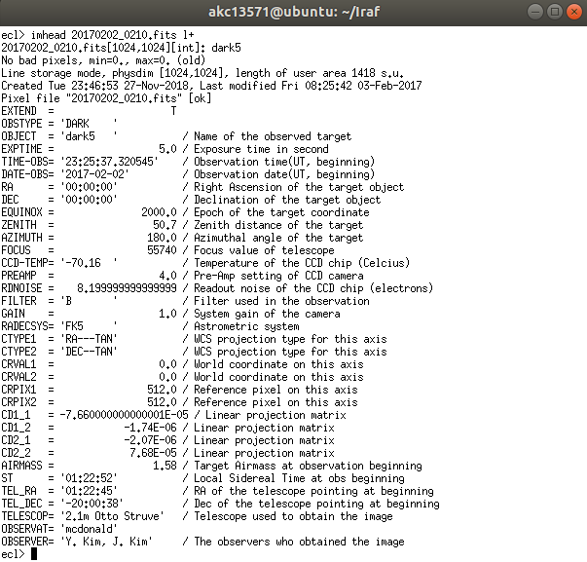

Image 1.5 The information of 20170202_0210 (Dark)

## 

## 

## 2. Pre-Processing

2.1 Zerocombine

* The resulting image of "Zero.fits”.

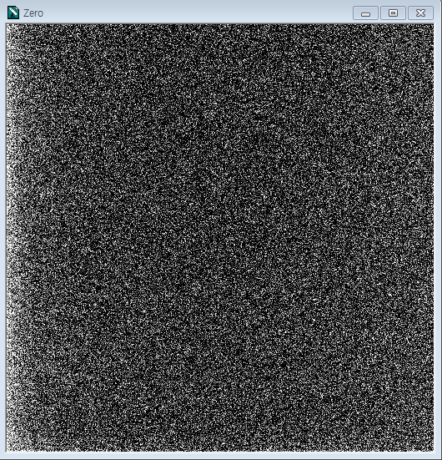

Image 2.1 Zero.fits

* The image information of “Zero.fits” using the ’ imstat ‘ task.

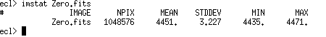

Image 2.2 information of Zero.fits

2.2 Darkcombine

* + The resulting image of “Dark.fits”.

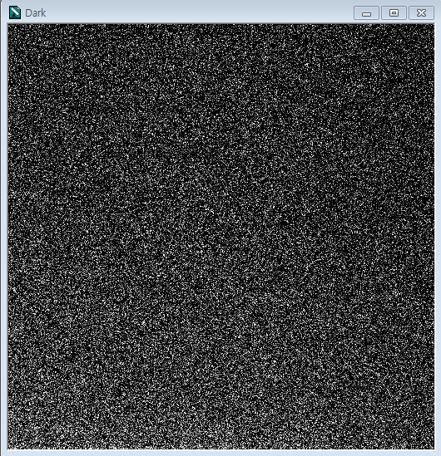

Image 2.3 Dark.fits

* The image information of “Dark.fits” using the ‘imstat’ task.

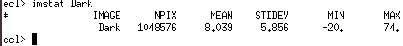

Image 2.4 Information of Dark.fits

2.3 Flatcombine

* The resulting image of “Flat.fits”.

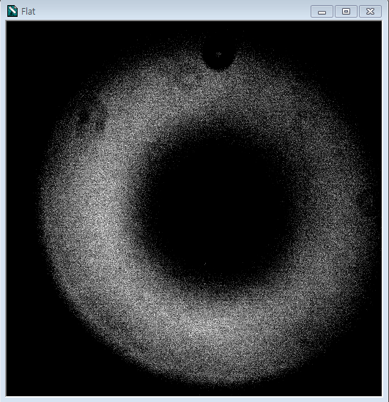

Image 2.5 Flat.fits

* The image information of “Flat.fits” using the ‘imstat’ task.

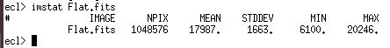

Image 2.6 Information of Flat.fits

2.4 Object Processing

* The object image before and after processing.

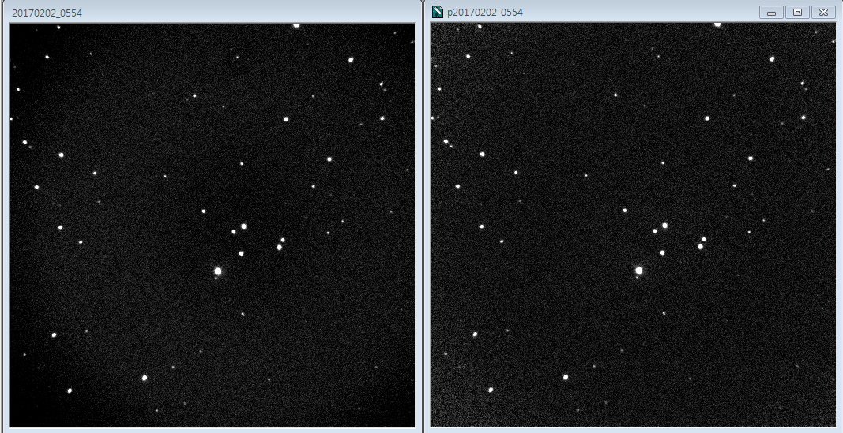

Image 2.7 Object before processing(left) and after processing(right)

## 3. Aperture Photometry

3.1 Image alignment

* Write the x,y coordinates of the selected star of each image.

pB1 : x = 270.86 , y = 482.89

pB2 : x = 270.65 , y = 477.97

pB3 : x = 271.16 , y = 482.75

* Write the difference value of the x, y coordinates between pB1 and pB2, pB1 and pB3.

difference(pB1-pB2) : x = 0.21, y = 4.92

difference(pB1-pB3) : x = -0.3, y = 0.14

Additionally, I have attached the Image 3.1 of coordinates extracted by the ‘imexamine’ task.

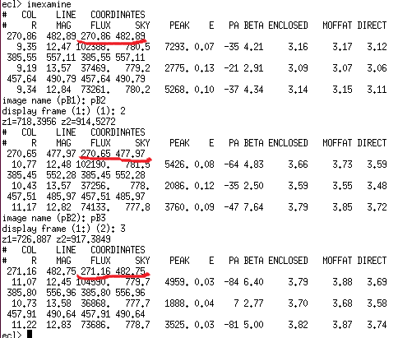

Image 3.1 information of stars by ‘imexamine’

3.2 Image combine

* Use a screenshot, attach the resulting images of "NGC225B.fits".

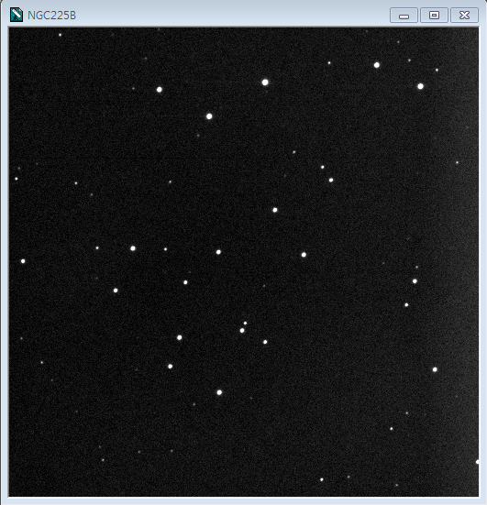

Image 3.2 NGC 225B.fits

3.3 Parameter settings

* Write the average values of "SKY, SKYSIGMA, FWHM" using daoedit task

The value of 5 stars using the daoedit task in ds9 is like this.

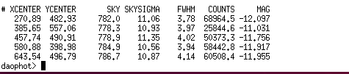

Image 3.3 NGC 225B.fits

So, by calculation, the average value of "SKY, SKYSIGMA, FWHM" is like this.

Average of SKY = 782.16

Average of SKYSIGMA = 10.954

Average of FWHM = 3.97

* Write the calculate values of "annulus, dannulu".

So, the calculation values of "annulus, dannulu" is like this.

“annulus” = 4 * FWHM = 4 * 3.97 = 15.88

“Dannulu” = 2~3 * FWHM = 3 * 3.97 = 11.9

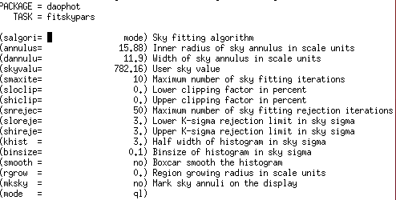

Image 3.4 ‘fitskypars’ task

3.4 Finding Stars

* Use a screenshot, attach the resulting images using daofind and tvmark task as shown tutorial page 8.

I have attached the image as Image 3.5.

(due to the limit of size in ds9, I had to take two screenshots and combine the image.So there is a line at the middle of the image.)

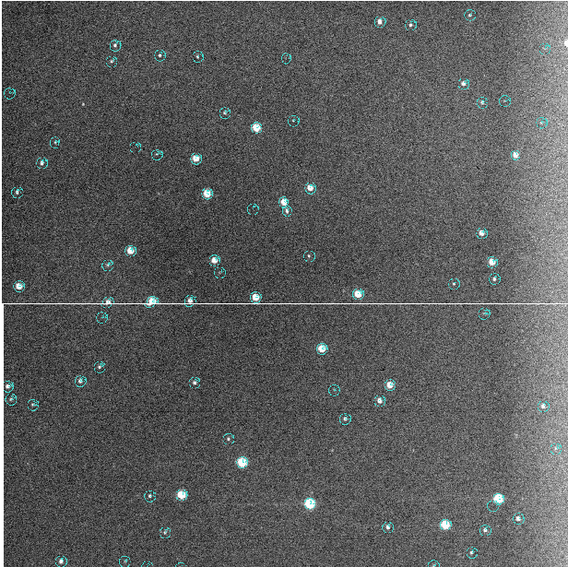

Image 3.5 Resulting images using daofind and tvmark task

3.5 Aperture Photometry

* Upload your final result, "NGC225B.dat" file.

This is the link of my ‘dat’ file.

<https://drive.google.com/file/d/1K8CNQ2C2PUNVrzrhHzYhGiawyezpwLxX/view>

* How many stars are listed in your ".dat" file?

The total star listed in my “dat” file are 72 stars. I have two values with error, ID 1 and 2.

To count the stars in my “dat” file, I have attached the image of the list in Image 3.6, 3.7, 3.8.

The header of each columns are “Image, ID , XCENTER, YCENTER, FLUX, MAG, MERR” in order. I explained the meanings of each headers.

Image : The name of the image which was processed through photometry.

ID : ID numbers of the stars in the image.

XCENTER : The x coordinate of the center of the star.

YCENTER : The y coordinate of the center of the star.

FLUX : The sum of the pixels in the aperture which is calculated as flux = sum - area * msky

MAG : The instrumental magnitude of the star. mag = zmag - 2.5 * log10 (flux) + 2.5 * log10 (itime)

MERR : The value of the error of magnitude calculated as merr = 1.0857 * error / flux .

Additionally, error = sqrt (flux / epadu + area * stdev**2 +area**2 * stdev**2 / nsky)

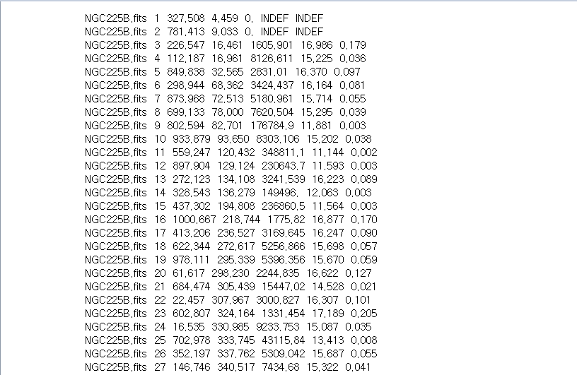

Image 3.6 list of stars ID 1-27

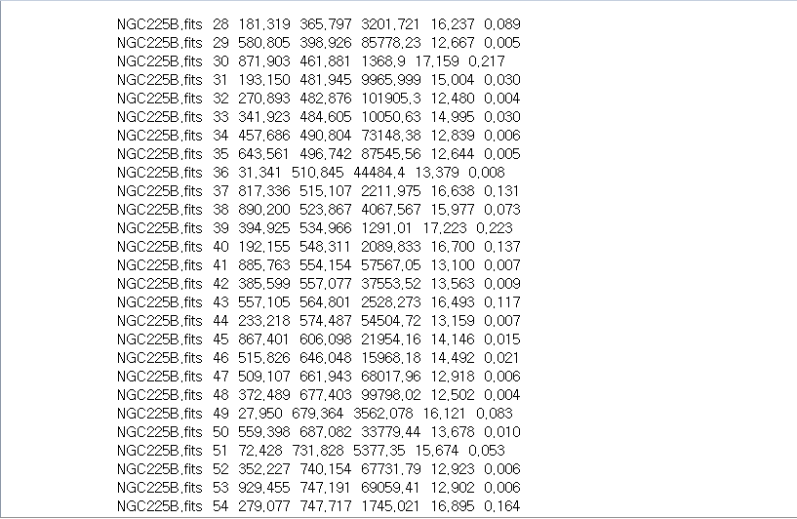

Image 3.7 list of stars ID 28-54

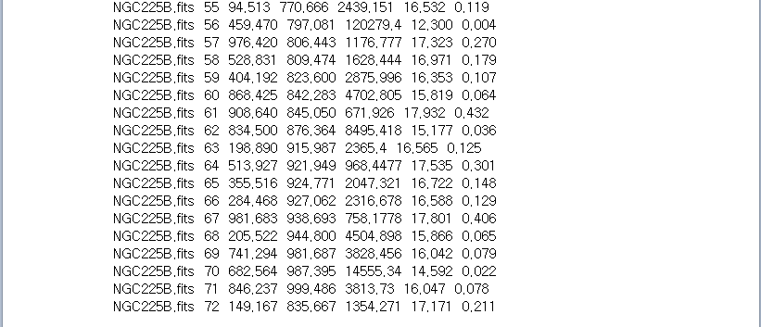

Image 3.8 list of stars ID 55-72

# Project 05. Data Reduction & Results using My data

* What is your assignment in this project?

This is the last project of this semester. My assignment in this project is preprocessing and doing photometry on my own observation data of NGC7086. After that, using the data from the previous process, The flux will be calibrated and the H-R diagram will be plotted by the flux-calibrated data. By analyzing the data that I observed and calibrated, I hope to fully review about observation I learned this semester. Going through the whole process that we learned in this semester, from preparing observation to plotting the H-R diagram, this is the final result of this report.

## 5.1. Preprocessing

* For process of preprocessing, refer to the Project 04, or IRAF tutorial of WP&BS&TJ.

5. 1. 1 Bias image

* This is the Image and the plot of the master bias. (10 Bias combined, see Project03. 4.2.2)

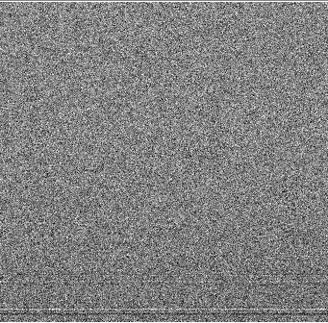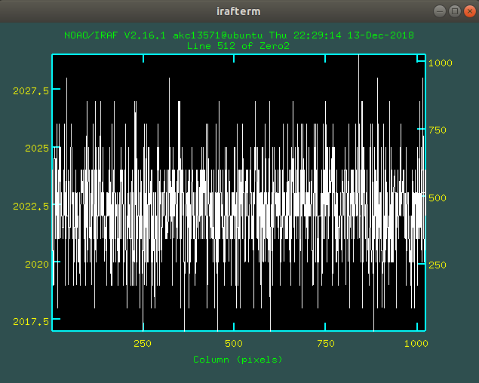

Image 1.1 Master Bias image and plot

5. 1. 2 Dark image

* This is the each Image and the plot of the master dark for B,V. I used different frame of Dark for B and V because the exposure time for each object was different.(10 Dark combined for each see Project03. 4.2.3)

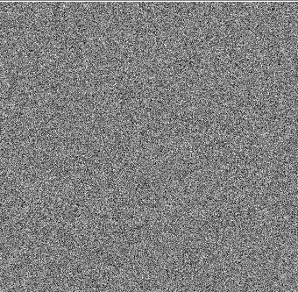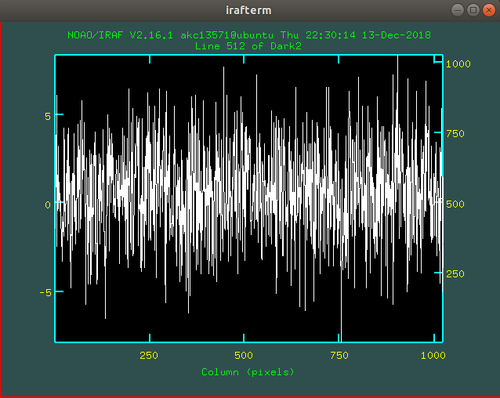

Image 1.2 Master Dark image and plot for B

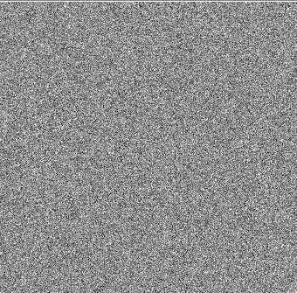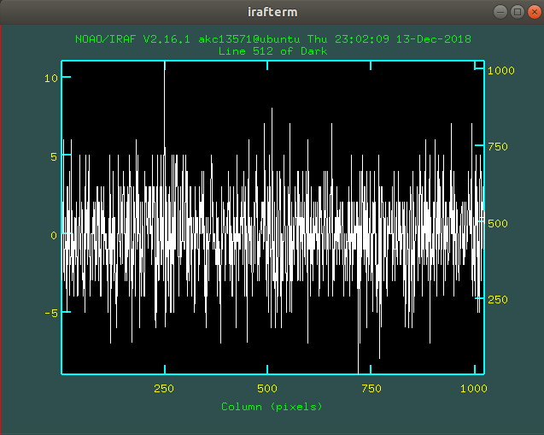

Image 1.3 Master Dark image and plot for V

5. 1. 3 Flat image

* This is the each Image and the plot of the master flat for B,V.

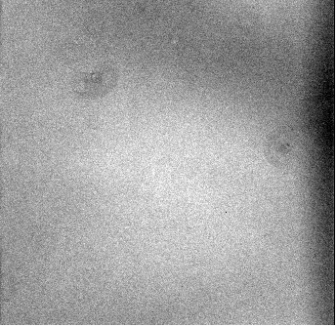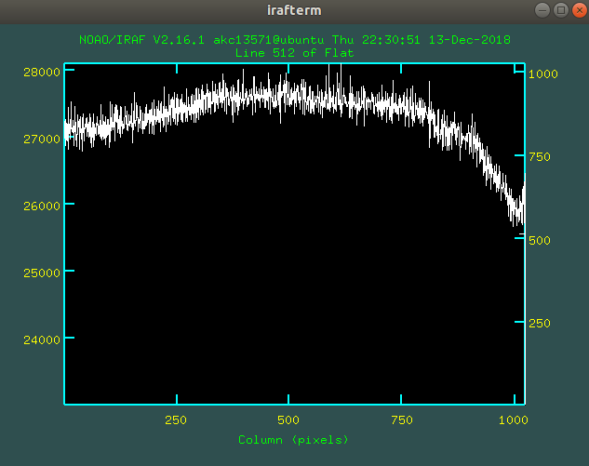

Image 1.4 Master flat image and plot for B

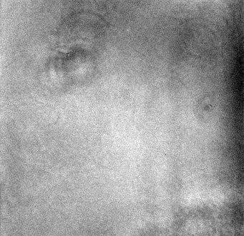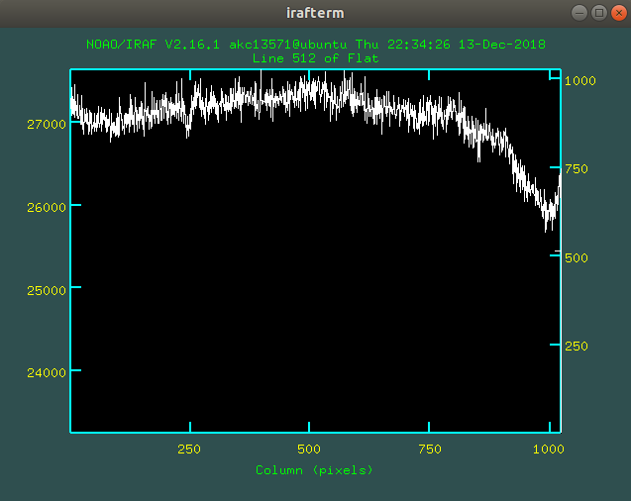

Image 1.5 Master flat image and plot for V

5. 1. 4 Image processing & Combining to get B-frame and V-frame

* After Image processing using ccdproc task of IRAF, this is the preprocessed data.

You can refer to image processing part of the IRAF tutorial. I selected specific 5 or 6 images for each B and V filter because there were some images that were flewed. I discluded those images.

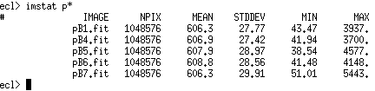

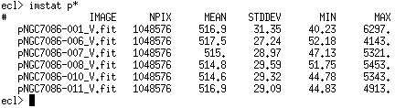

Image 1.6 stats of processed images for B,V

Then we are going to combine these images after shifting image using ‘imshift’ and then using ‘imcombine’ task. By using ‘imexamine’ task and ‘a’ in ds9, you can find the coordinates of stars for each images. After finding the coordinates, you have to calculate the difference between the main images. I will attach the paper for calculation for shifting the coordinates.

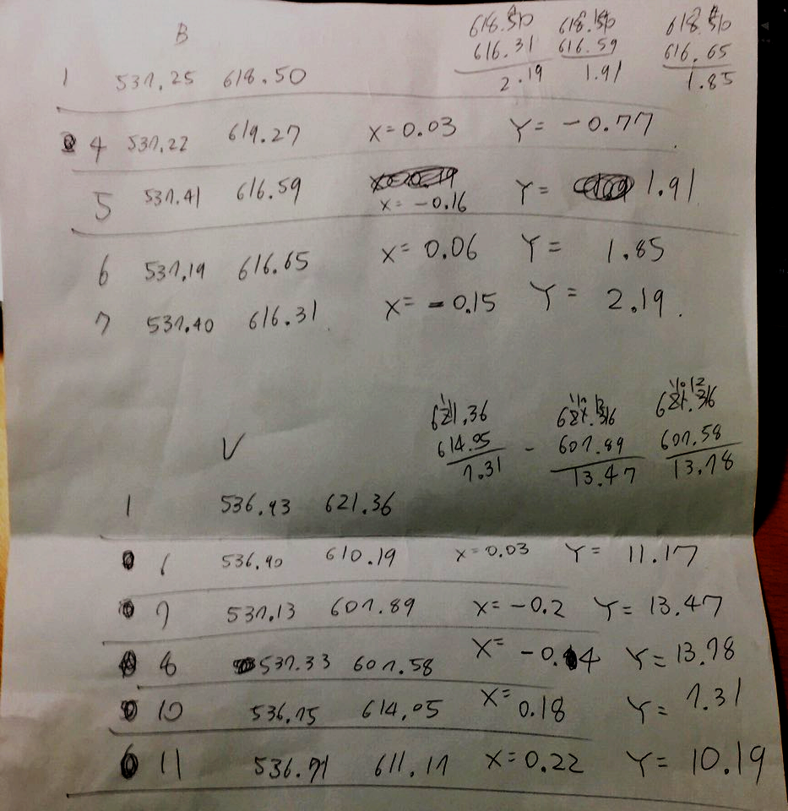

Image 1.7 Calculating differences to shift images

After the shifting is complete, you can combine the images. This is the finally combined images.

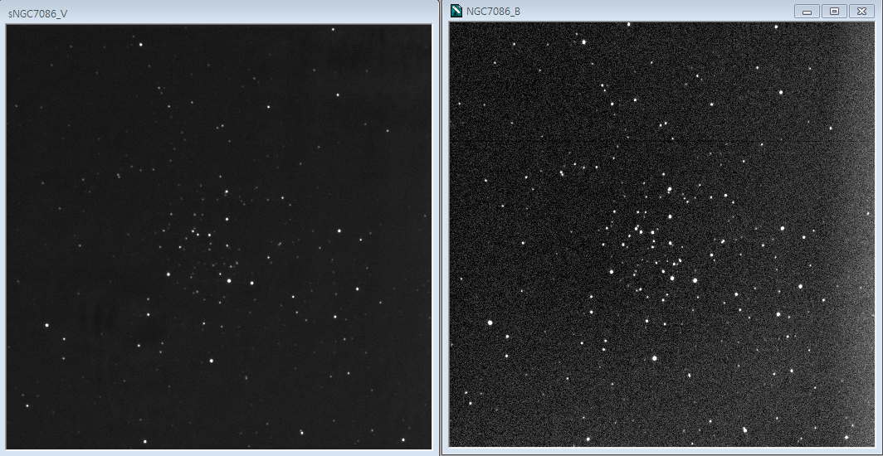

Image 1.8 Combined frames of NGC7086 (V-Frame for left, B-frame for right)

## 5.2. Photometry

* Using aperture photometry method, derive ID, XCENTER, YCENTER, FLUX.

To know the details of how the process goes, you can refer to Project 04, 3.Aperture photometry or photometry part of the IRAF tutorial.

* This is the address of my dat file and fits file in google drive.

<https://drive.google.com/drive/folders/1h7nRQlOuu44rpGjrXonmjVu4Dfhq5tki>

This is the example image of my dat.file for each B and V filter.

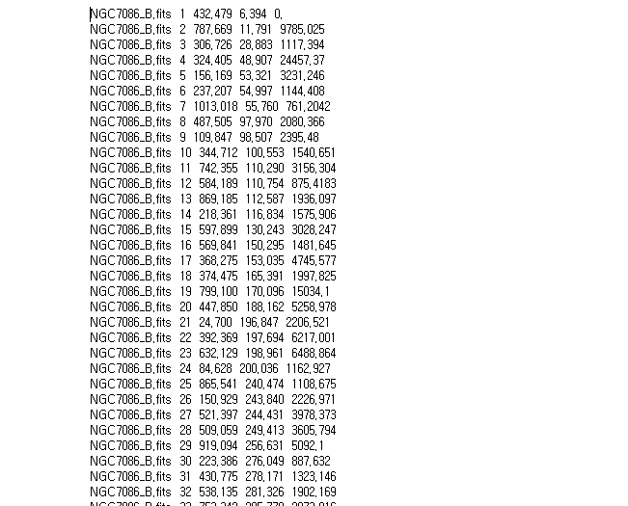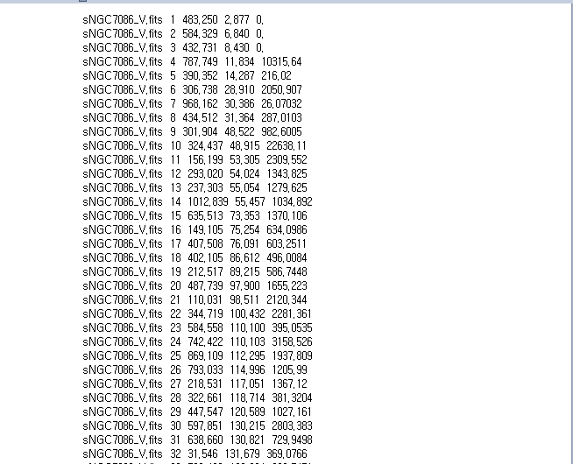

Image 2.1 example image of dat file for B and V (B is left, V is right)

## 5.3. Flux calibration

5. 3.1 Derive Zero Point

* Make a table using an Excel or Google Sheet file to list the followings:

Webda: ID, m_B, m_V, ID from your photometry results

B-frame: X_B, Y_B, F_B

V-frame: X_V, Y_V, F_V

Calculate ZP_B and ZP_V: m_STD = ZP - 2.5 log F

This is the address of my google sheet.

<https://docs.google.com/spreadsheets/d/1R1VKifTKgqTWPrj4-k8ltmvyc40v2gw8I2Hg6l2GuD8/edit#gid=0>

I will attach an image of the Zero point deriving part.

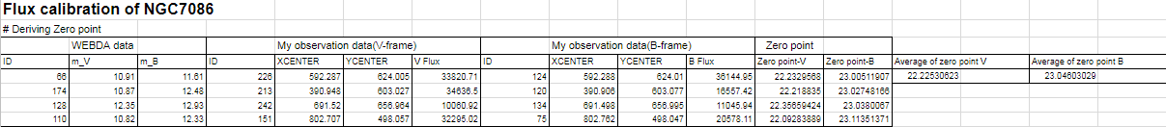

Image 3.1 deriving the Zero point

* I used 4 stars to derive the average of Zero points calculated from ZP_B and ZP_V: m_STD = ZP - 2.5 log F. However, to find the same stars from WEBDA and my observation data, I compared the image by enlarging images and finding the same stars with eyes. I had to find the ID from ds9 and find the information in dat file. These are the comparison images.

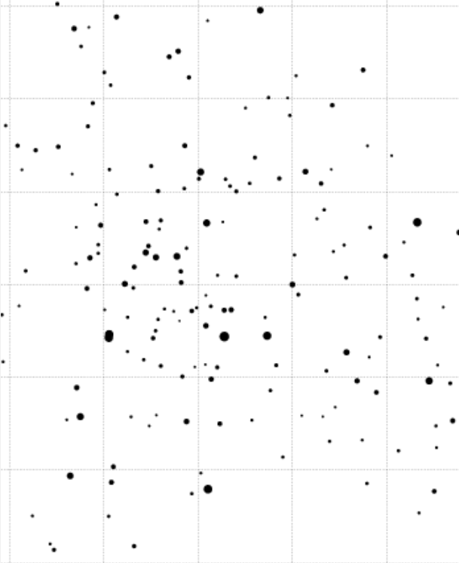

Image 3.2 Finding chart from WEBDA(enlarged)

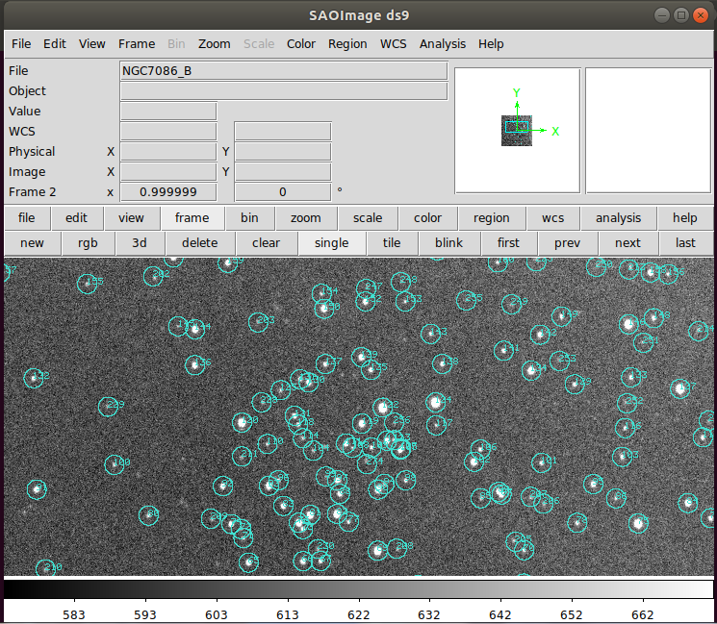

Image 3.3 Comparison image for B

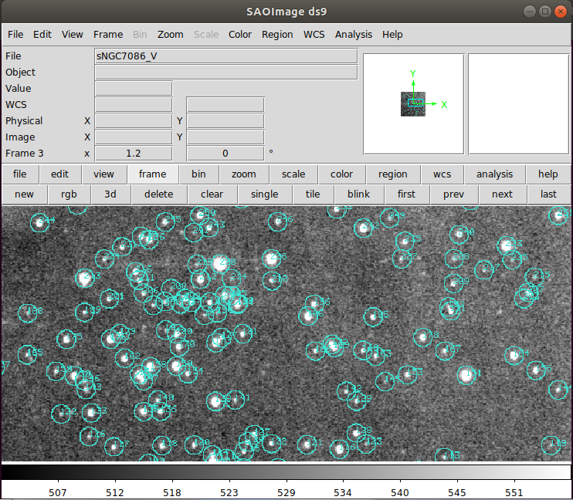

Image 3.4 Comparison image for V

5.3.2 Derive Calibrated Magnitude

* After deriving the zero point, I copy and pasted the dat file of each B filter and V filter to the excel and made a table in google spreadsheet. However, to make the information to be divided to each cell, click ‘데이터’ tab and click ‘텍스트를 열로 분할’ in the state of the cell that you want to divide is selected.
* The excel sheet or google spreadsheet has to include these datas. ID from your photometry results, X_B, Y_B, F_B, X_V, Y_V, F_V

And final Calculation of m_B and m_V: m = ZP - 2.5 log F

This is my google sheet again. Please refer to this sheet.

<https://docs.google.com/spreadsheets/d/1R1VKifTKgqTWPrj4-k8ltmvyc40v2gw8I2Hg6l2GuD8/edit#gid=0>

* This is the image that is representing the part of table for the data after photometry of NGC7086. The table goes on until ID 360 for V, and ID 267 for B.

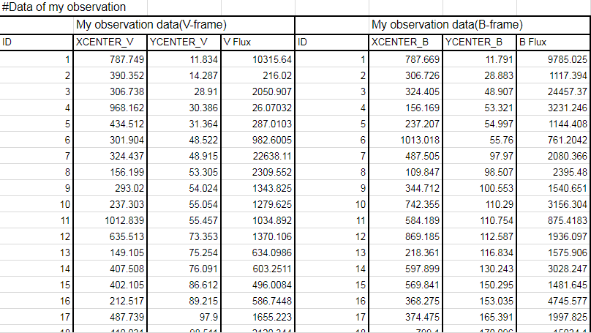

Image 3.5 Table of data from photometry of NGC7086

* However, after calculating the magnitude, I recognized that I had to match each stars of V-frame, and B-frame to derive the m_B-V. So, I started to match each stars by matching the coordinates because I shifted the V-frame using the difference of coordinates with B-frame. It took lot’s of time but I finally could match the stars of V-frame and B-frame. The part of the result is Image 3.6.

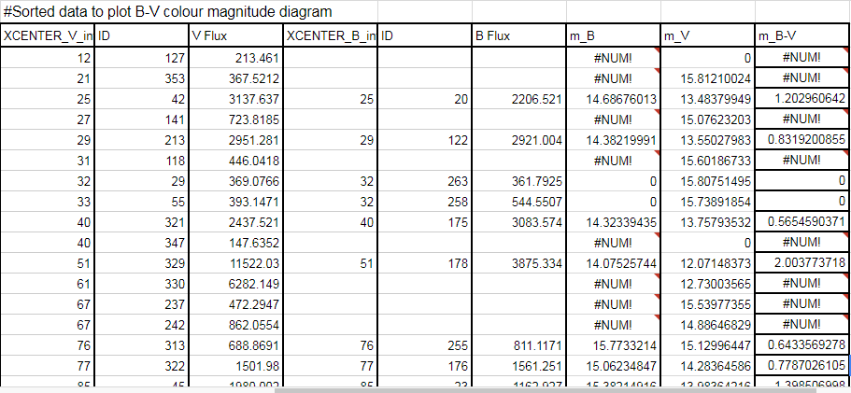

Image 3.6 Sorted data to plot B-V colour magnitude diagram

Especially, I used IF functions in the spreadsheet to cut off the data that are useless. Please refer to the google spreadsheet.

## 5.4. H-R Diagram

* So this is the H-R Diagram that I plotted using the results of 5.3.

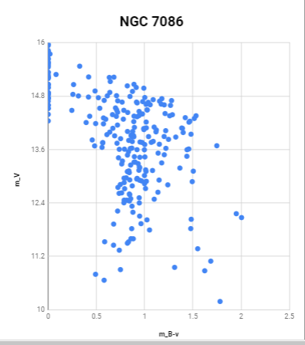

Image 4.1 The B-V colour magnitude diagram of NGC7086

* I have compared this with the diagram on WEBDA. (There are no way to change the order of the y-axis in google spreadsheet, so I flipped Image 4.1)

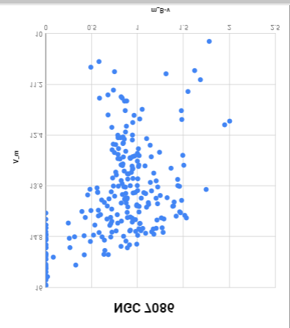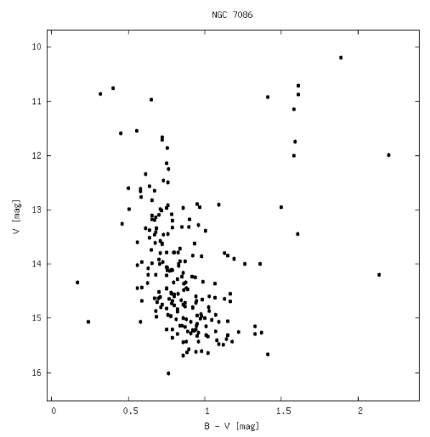

Image 4.2 Comparison of Image 4.1(flipped) and H-R diagram of NGC7086(WEBDA)

Ref : <https://www.univie.ac.at/webda/cgi-bin/plot_cmd.cgi?ngc7086+NGC+7086>

## 5.5. Final comments

5.5.1 The reasons why there is difference with the WEBDA diagram

* 1) Stars that are assumed not to be the member of NGC7086

Finally, I plotted the H-R diagram. However, there were some differences with the WEBDA data. The difference was like image 5.1 .

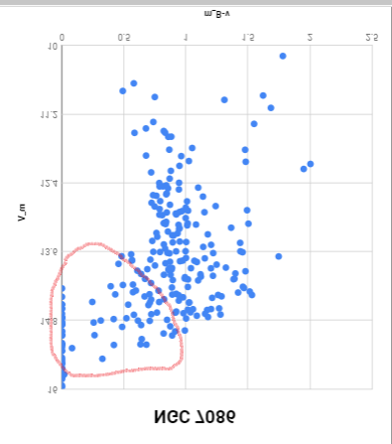

Image 5.1

As I circled in image 5.1, the circled part is different with the WEBDA H-R diagram of NGC 7086. So, I analyzed why these stars appeared in the H-R diagram of NGC7086.

First, these stars have lower magnitudes in the range of 14~16. It is relatively dark than other stars in the cluster. This means that they have a lower flux from photometry, so the dark objects which are not a star can be selected as a star by ‘daofind’ task.

Next, these stars are quite far from the main sequence of the cluster. Because these stars have B-V magnitude close in the range of 0~0.5 and the magnitude have a range of 14~16, I can assume that these stars doesn’t join to the main sequence of the open cluster NGC7086.

Therefore, I could conclude that these stars are not the members of NGC7086. To confirm this, I should find out the ID and coordinates of those stars. Then I can presume that these stars will not only distribute on the edge of the observed image, but also not distributing in the center side.

There is one definite way to confirm if these stars are the members of NGC7086. It is to have a spectroscopic observation of these stars. After knowing the doppler shift and the mechanical movements of these stars, we can compare with stars that are definitely members of NGC7086. Then if they are not the members of NGC7086, they will have different movements within the stars in NGC7086.

2) The difference of stars inside NGC7086.

The stars inside the cluster are not exactly same. They have different values in magnitude. Why did this happen? This is because of the zero point is not totally same for all of the analyzed stars. There are some errors in photometry.

Additionally, the weather when I observed the object wasn’t that perfect and there are some unknown noise in the V filter image, which could be caused from the telescope’s mechanism with the filter. These are some factors that could make the data unaccurate.

So, There are many ways to find out the errors of the diagram. However, I have learned additionally that I should pay more attention when finding stars in aperture photometry process using ‘tvmark’ task, because I can sort out the candidates that could not be the members of the open cluster.

5.5.2 Final comment of the class.

* I could learn the whole process of astronomical observation during this class. This report is so precious to me now and I think I will always refer to this report when I need to observe. I hope many other students could learn about observation and astronomy by this class and could have some help from this report. Thanks to giving us chance to learn about astronomical observation. Thank you so much prof. Soojong Park, and thanks to Tae geun Ji, and Sun woo Lee for the kindful and wonderful help and assistance for students.